# Cognitive Reflection Test Measure

**[Measure: Cognitive Reflection Test 2]**

Instructions: On the next few pages are several problems that vary in difficulty. Try to answer as

many as you can.

• If you’re running a race and you pass the person in second place, what place are you in?   
(intuitive answer: first; correct answer: second)

• A farmer had 15 sheep and all but 8 died. How many are left?   
(intuitive answer: 7; correct answer: 8)

• Emily’s father has three daughters. The first two are named April and May. What is the third daughter’s name?   
(intuitive answer: June; correct answer: Emily)

• How many cubic feet of dirt are there in a hole that is 3’ deep x 3’ wide x 3’ long?   
(intuitive answer: 27; correct answer: none)

Note: Text in gray above is not shown to participants.

# Health Literacy Measure

**[measure: Newest Vital Sign]**

**Instructions**: The information shown in the image below is on the back of a container of a pint of ice cream. Use this image to answer the following questions.

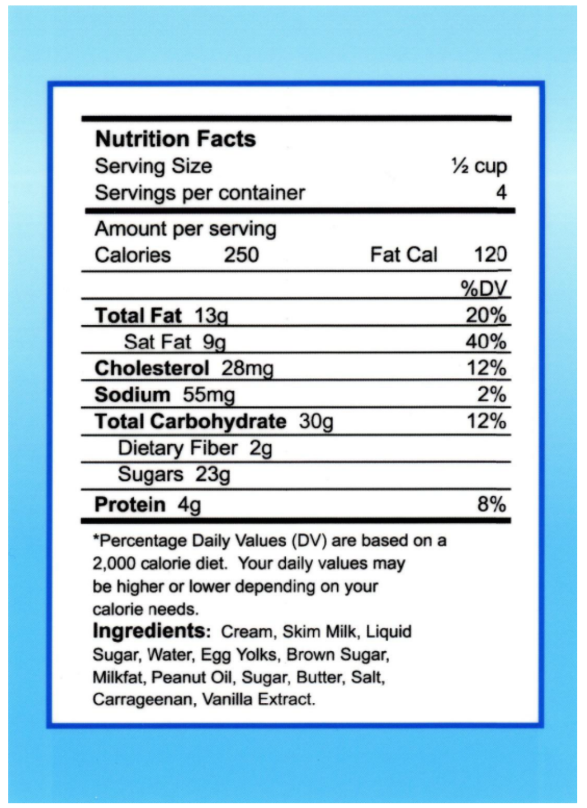

Q1. Using the image above...

If you eat the entire container, how many calories will you eat?

**[short answer input] [correct answer: 1,000]**

Q2. Using the image above...  
If you are allowed to eat 60 grams of carbohydrates as a snack, how much ice cream could you have?

**[short answer input] [Correct answer: either: 1 cup, 1 cup or less, any amount up to 1 cup, a quarter of the container, 2 servings]**

Q3. Using the image above...  
Our doctor advises you to reduce the amount of saturated fat in your diet. You usually have 42 g of saturated fat each day, which includes one serving of ice cream. If you stop eating ice cream, how many grams of saturated fat would you be consuming each day?

**[short answer input] [Correct answer: 33]**

Q4. Using the above image...  
If you usually eat 2,500 calories in a day, what percentage of your daily value of calories will you be eating if you eat one serving?

**[short answer input] [Correct answer: either: 10% or 10 or .10]**

Q5. Using the image above...  
Pretend that you are allergic to the following substances: penicillin, peanuts, latex gloves, and bee stings. Is it safe for you to eat this ice cream?

* Yes
* No
* Maybe / Unsure
* Other [fill in the blank]

**[Correct answer: no]**

***[Note: Q6 is only shown if participant answers ‘no’ to Q5.]***

Q6. Using the image above... AND pretending you are allergic to the following substances: penicillin, peanuts, latex gloves, and bee stings -- Why is it not safe for you to eat this ice cream?

**[short answer input] [Correct answer: Because it has peanut oil]**

# Sleep Questionnaire

Instructions: In the following section you will answer questions related to your sleeping habits.

1. What time do you typically go to sleep on workdays?
2. What time do you typically wake up of workdays?
3. What time do you typically go to sleep on non-workdays?
4. What time do you typically wake up on non-workdays?

# Demographic Questionnaire

1. What is your age (in years)?
2. What is your gender?
   1. Male
   2. Female
   3. Non-binary
   4. Other / prefer not to say
3. What ethnicity do you consider yourself to be?
   1. American Indian / Alaska Native
   2. Asian
   3. Black / African American
   4. Hispanic / Latino
   5. Native Hawaiian / Other Pacific Islander
   6. White / Caucasian
   7. Other
4. Do you live in the United States of America?
   1. Yes
   2. No
5. What is the highest level of education you have attained?
   1. Not applicable
   2. I did not attend high school
   3. I did not complete high school
   4. I completed high school or got a G.E.D.
   5. I completed some college classes but did not receive a degree
   6. I received an associate's degree
   7. I received a bachelor’s degree
   8. I attended graduate school but did not receive a degree
   9. I received a graduate degree (master's, MBA, Ph.D., etc)
6. We hear a lot of talk these days about liberals and conservatives. Here is a seven-point scale on which the political views that people might hold are arranged from extremely liberal to extremely conservative. Where would you place yourself on this scale?
   1. 1. Extremely liberal
   2. 2. Liberal
   3. 3. Slightly liberal
   4. 4. Moderate; middle of the road
   5. 5. Slightly conservative
   6. 6. Conservative
   7. 7. Extremely conservative

# Misinformation Measure

Overview: *The misinformation task will involve participants reviewing headlines (with an accompanying photo) and assessing the veracity of the information.* *We have included URL’s for the news sources. The URL’s will not be present during a participant’s study experience.*

The headlines and photos (shown below) will be followed with a question used to measure the extent to which participants believe the ‘news’ is true. For example, we may ask questions like: “Answer on the slider below, to what extent you believe the above headline represents accurate/true news (0 = do not believe it is true at all; 100=believe it is completely true). An example slider scale is shown below in Figure 1. Participants will also be asked to rate their confidence after each news item. For example, how confident are you in your assessment of the headlines’ truthfulness (0 = not at all confident; 100 = completely confident).

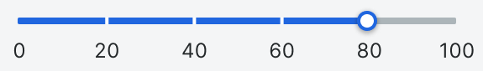

Figure 1. Example slider scale. Note: Actual study slider has different appearance and did not have anchor points between 0 and 100.

Within the misinformation block, half of the ‘news’ participants will see will be true and half will be misinformation (with a randomized presentation order). Participants’ task is to accurately determine which news is true and which is not.

The stimuli are separated into four sections:

1. fake news about Covid-19,
2. fake news about “the big lie” that former President Trump won the 2020 election,
3. true news about Covid-19, and
4. true news about “the big lie” that former President Trump won the 2020 election.

# Fake News

# Covid Vaccinations

## 01

### LA Sheriff's Dept. Forcibly Vaccinating People With Special Needs



Reference: <https://www.snopes.com/fact-check/lasd-forced-vaccination/>

<div style="display:relative; margin:0px; padding:0px"><img style="width: 1200px; height: 800px; margin:0px; padding:0px" src="https://ohsu.ca1.qualtrics.com/CP/Graphic.php?IM=IM_d75kgVOX1krfef4"></div>

<div style="position:relative; margin:0px; padding:0px; top:-8px; height:100px; width:100%; background-color:lightgray; padding:10px; font-weight:bold; font-size:1.3em">LA Sheriff's Dept. forcibly vaccinating people with special needs <img style="width: 25px; height: 25px;" src="https://ohsu.ca1.qualtrics.com/CP/Graphic.php?IM=IM_0pSmTtfRTtUtj3o"></div>

## 02

### Pfizer's COVID-19 vaccine caused the death of Florida doctor Gregory Michael

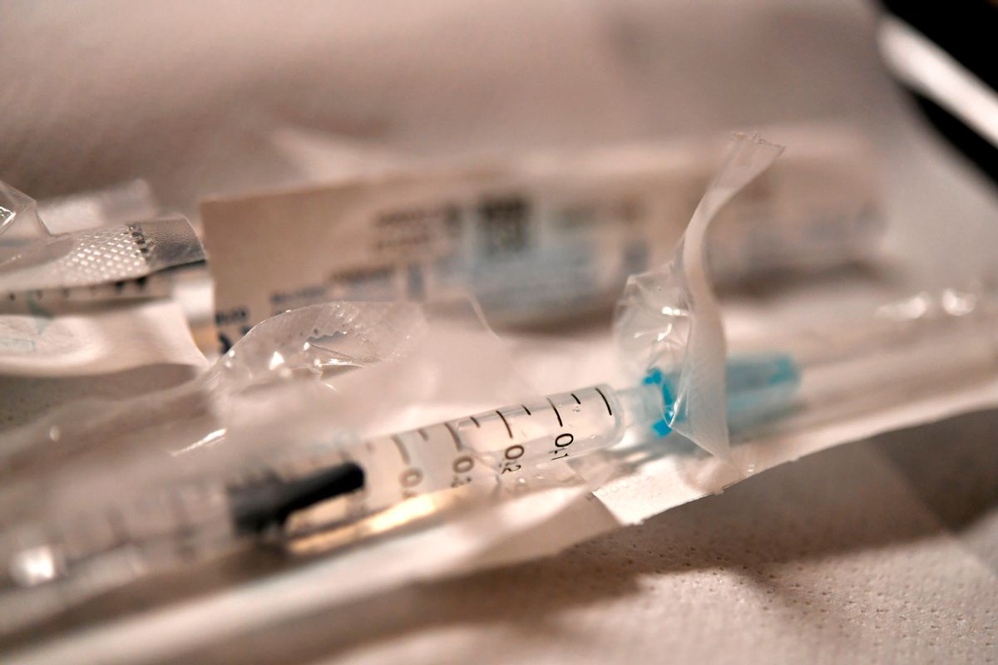

Reference: <https://www.snopes.com/fact-check/gregory-michaels-itp/>

<div style="display:relative; margin:0px; padding:0px"><img style="width: 1200px; height: 800px; margin:0px; padding:0px" src="**https://ohsu.ca1.qualtrics.com/CP/Graphic.php?IM=IM_cOcINQ55AIq9h9J**"></div>

<div style="position:relative; margin:0px; padding:0px; top:-8px; height:100px; width:100%; background-color:lightgray; padding:10px; font-weight:bold; font-size:1.3em">**Pfizer's COVID-19 vaccine caused the death of Florida doctor Gregory Michael**<img style="width: 25px; height: 25px;" src="https://ohsu.ca1.qualtrics.com/CP/Graphic.php?IM=IM_0pSmTtfRTtUtj3o"></div>

## 03

### A Portuguese nurse named Sonia Azevedo died from adverse side effects from the Pfizer-BioNTech COVID-19 vaccine

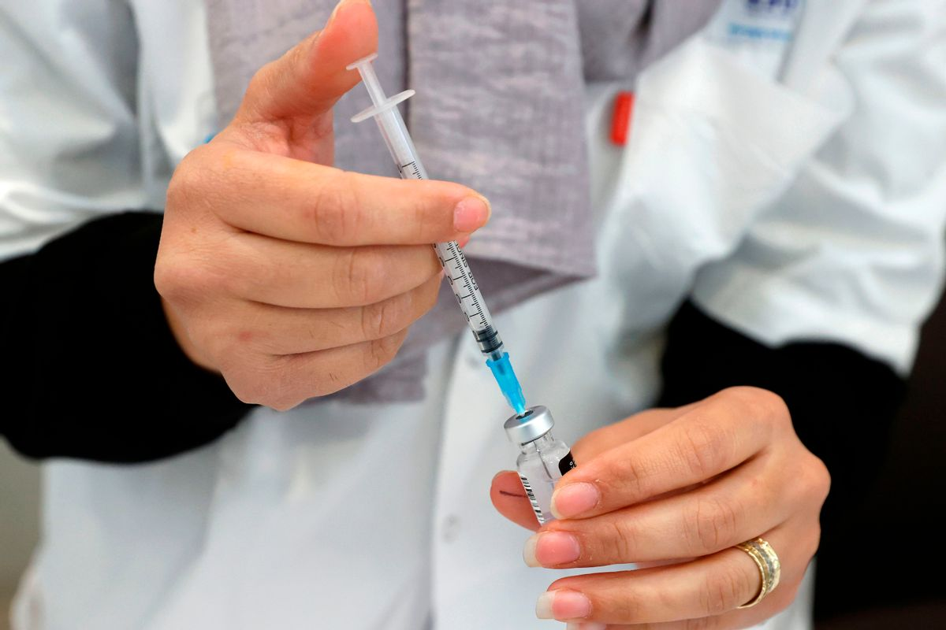

Reference: <https://www.snopes.com/fact-check/portuguese-nurse-dies-vaccine/>

<div style="display:relative; margin:0px; padding:0px"><img style="width: 1200px; height: 800px; margin:0px; padding:0px" src="**https://ohsu.ca1.qualtrics.com/CP/Graphic.php?IM=IM_Liuo1UH6aRh9waY**"></div>

<div style="position:relative; margin:0px; padding:0px; top:-8px; height:125px; width:100%; background-color:lightgray; padding:10px; font-weight:bold; font-size:1.3em">**A Portuguese nurse named Sonia Azevedo died from adverse side effects from the Pfizer-BioNTech COVID-19 vaccine**<img style="width: 25px; height: 25px;" src="https://ohsu.ca1.qualtrics.com/CP/Graphic.php?IM=IM_0pSmTtfRTtUtj3o"></div>

## 04

### New study proves that the higher a country’s vaccination rate is, the higher the excess death rate in that country will be

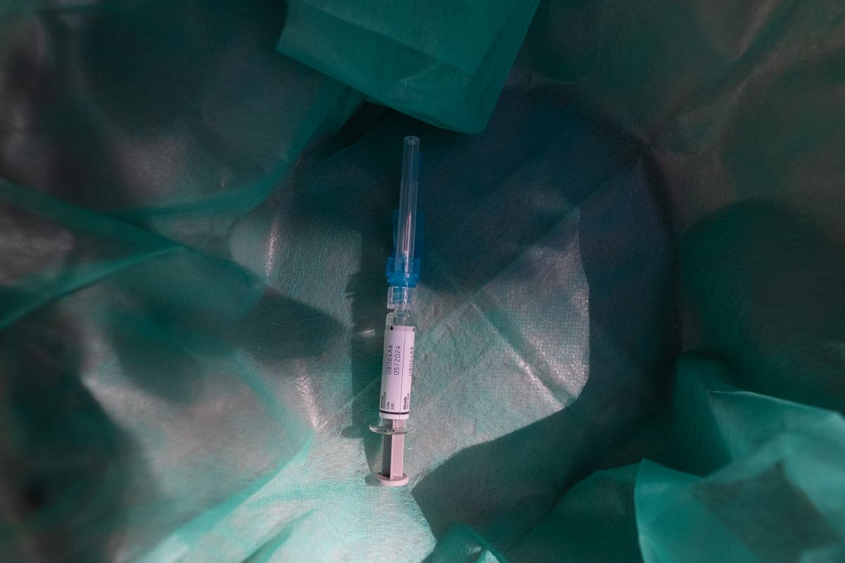Reference: <https://www.snopes.com/fact-check/vaccination-rate-excess-deaths/>

<div style="display:relative; margin:0px; padding:0px"><img style="width: 1200px; height: 800px; margin:0px; padding:0px" src="**https://ohsu.ca1.qualtrics.com/CP/Graphic.php?IM=IM_74J8HDdbAhySKs6**"></div>

<div style="position:relative; margin:0px; padding:0px; top:-8px; height:125px; width:100%; background-color:lightgray; padding:10px; font-weight:bold; font-size:1.3em">**New study proves that the higher a country’s vaccination rate is, the higher the excess death rate in that country will be** <img style="width: 25px; height: 25px;" src="https://ohsu.ca1.qualtrics.com/CP/Graphic.php?IM=IM_0pSmTtfRTtUtj3o"></div>

## 05

### European Medicines Agency (EMA) says that COVID-19 vaccines could have an adverse effect on female fertility

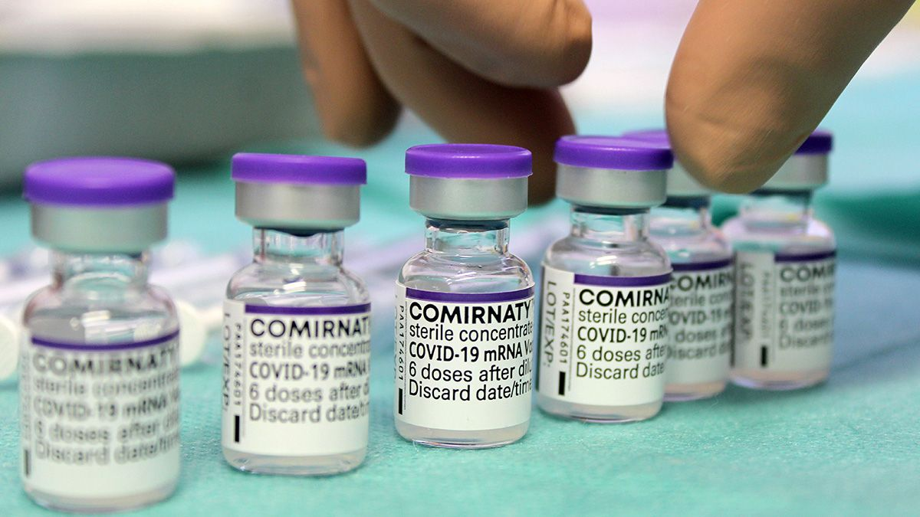

Reference: <https://www.snopes.com/fact-check/ema-covid-vaccines-fertility/>

<div style="display:relative; margin:0px; padding:0px"><img style="width: 1200px; height: 800px; margin:0px; padding:0px" src="**https://ohsu.ca1.qualtrics.com/CP/Graphic.php?IM=IM_digHAJP0386p5oq**"></div>

<div style="position:relative; margin:0px; padding:0px; top:-8px; height:125px; width:100%; background-color:lightgray; padding:10px; font-weight:bold; font-size:1.3em">**European Medicines Agency (EMA) says that COVID-19 vaccines could have an adverse effect on female fertility** <img style="width: 25px; height: 25px;" src="https://ohsu.ca1.qualtrics.com/CP/Graphic.php?IM=IM_0pSmTtfRTtUtj3o"></div>

## 06

### Africa is only 6% vaccinated and yet Covid has practically disappeared

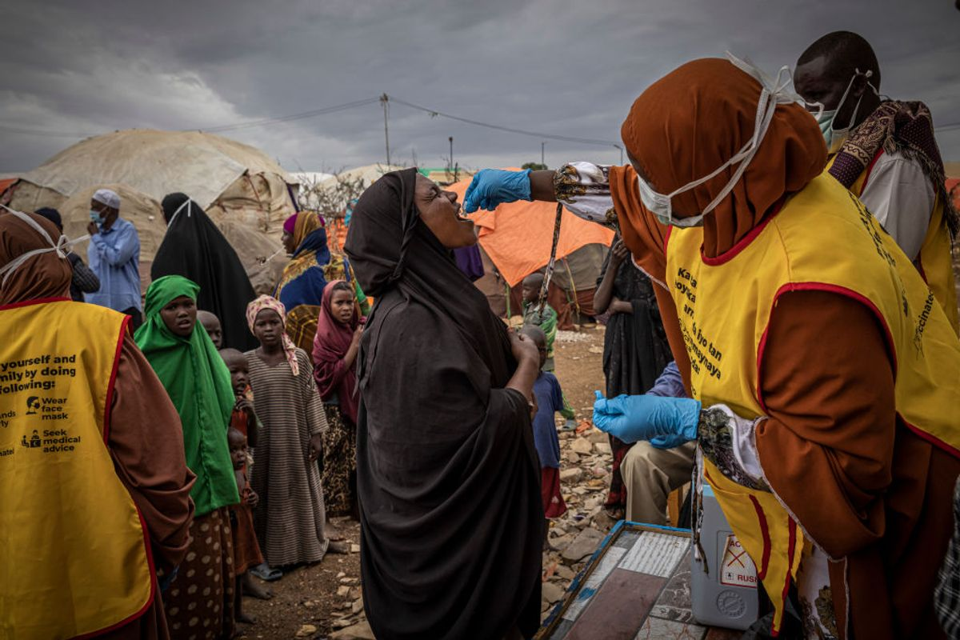

Reference: https://www.snopes.com/news/2023/01/05/covid-vaccine-africa/

Reference: <https://www.snopes.com/fact-check/ema-covid-vaccines-fertility/>

<div style="display:relative; margin:0px; padding:0px"><img style="width: 1200px; height: 800px; margin:0px; padding:0px" src="**https://ohsu.ca1.qualtrics.com/CP/Graphic.php?IM=IM_3kilGU2NjClmeVM**"></div>

<div style="position:relative; margin:0px; padding:0px; top:-8px; height:100px; width:100%; background-color:lightgray; padding:10px; font-weight:bold; font-size:1.3em">**Africa is only 6% vaccinated and yet Covid has practically disappeared**<img style="width: 25px; height: 25px;" src="https://ohsu.ca1.qualtrics.com/CP/Graphic.php?IM=IM_0pSmTtfRTtUtj3o"></div>

## 07

### A 2-year-old baby girl in Virginia died after being given the Pfizer COVID-19 vaccine

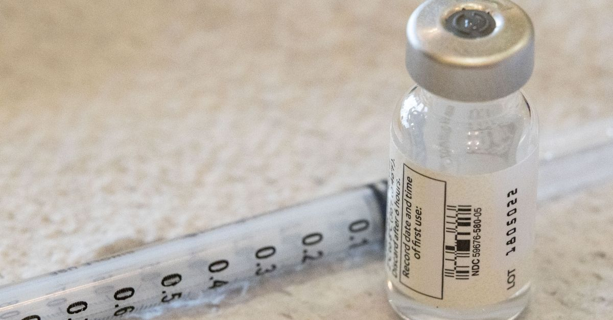

Reference: <https://www.>snopes.com/fact-check/two-year-old-virginia-die-vaccine/

<div style="display:relative; margin:0px; padding:0px"><img style="width: 1200px; height: 800px; margin:0px; padding:0px" src="**https://ohsu.ca1.qualtrics.com/CP/Graphic.php?IM=IM_3wo6F7X0WE8M3nU**"></div>

<div style="position:relative; margin:0px; padding:0px; top:-8px; height:100px; width:100%; background-color:lightgray; padding:10px; font-weight:bold; font-size:1.3em">**A 2-year-old baby girl in Virginia died after being given the Pfizer COVID-19 vaccine**<img style="width: 25px; height: 25px;" src="https://ohsu.ca1.qualtrics.com/CP/Graphic.php?IM=IM_0pSmTtfRTtUtj3o"></div>

## 08

### The head of Pfizer research said the COVID-19 vaccine developed by the pharmaceutical company "is female sterilization"

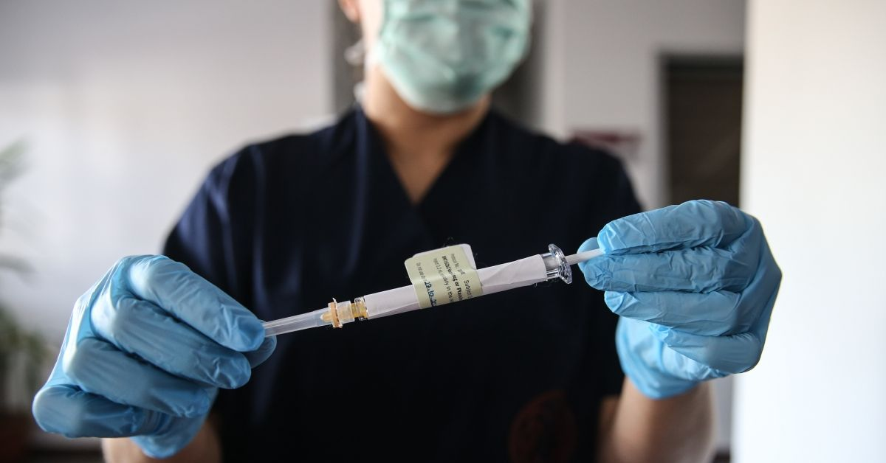

Reference: <https://www.snopes.com/fact-check/covid-vaccine-female-sterilization/>

<div style="display:relative; margin:0px; padding:0px"><img style="width: 1200px; height: 800px; margin:0px; padding:0px" src="**https://ohsu.ca1.qualtrics.com/CP/Graphic.php?IM=IM_3F4T7mSL2DltBdk**"></div>

<div style="position:relative; margin:0px; padding:0px; top:-8px; height:125px; width:100%; background-color:lightgray; padding:10px; font-weight:bold; font-size:1.3em">**The head of Pfizer research said the COVID-19 vaccine developed by the pharmaceutical company "is female sterilization"** <img style="width: 25px; height: 25px;" src="https://ohsu.ca1.qualtrics.com/CP/Graphic.php?IM=IM_0pSmTtfRTtUtj3o"></div>

## 09

### Chinese Scientists Created 'COVID-Like' Virus That Killed 100% Of Mice

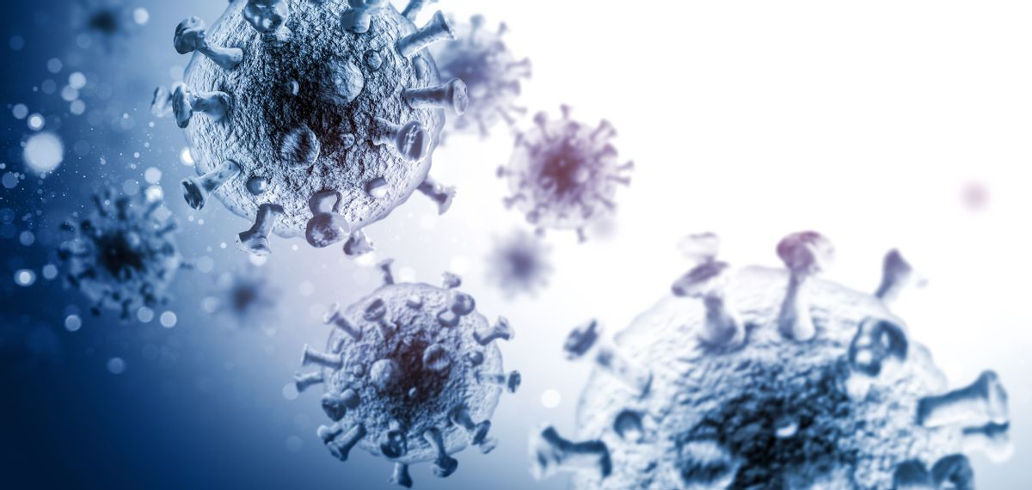

Reference: <https://www.snopes.com/news/2024/01/18/chinese-mutant-covid-19/>

<div style="display:relative; margin:0px; padding:0px"><img style="width: 1200px; height: 800px; margin:0px; padding:0px" src="**https://ohsu.ca1.qualtrics.com/CP/Graphic.php?IM=IM_6JqjwncBpkJ04WG**"></div>

<div style="position:relative; margin:0px; padding:0px; top:-8px; height:100px; width:100%; background-color:lightgray; padding:10px; font-weight:bold; font-size:1.3em">**Chinese scientists created 'COVID-like' virus that killed 100% of mice**<img style="width: 25px; height: 25px;" src="https://ohsu.ca1.qualtrics.com/CP/Graphic.php?IM=IM_0pSmTtfRTtUtj3o"></div>

## 10

### White House Emails Prove Biden Hid Deadly COVID Jab Risks from Public

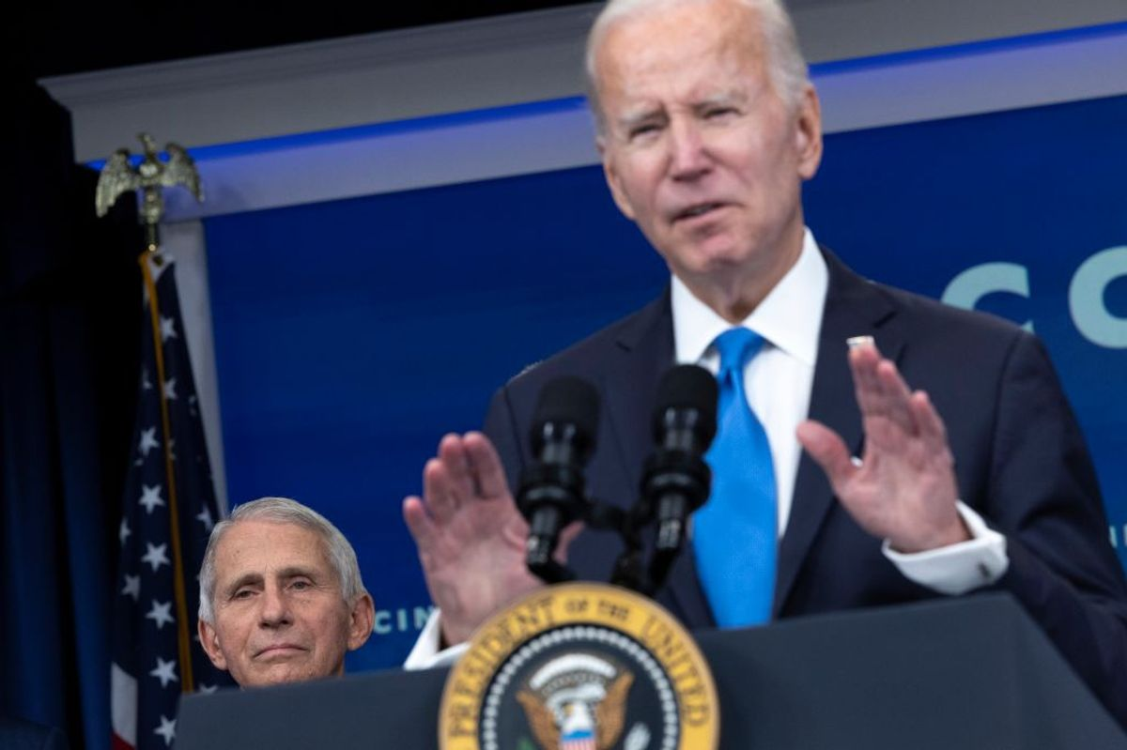

Reference: <https://www.snopes.com/fact-check/white-house-emails-hid-myocarditis/>

<div style="display:relative; margin:0px; padding:0px"><img style="width: 1200px; height: 800px; margin:0px; padding:0px" src="**https://ohsu.ca1.qualtrics.com/CP/Graphic.php?IM=IM_8wAcj5vDdJk3HTg**"></div>

<div style="position:relative; margin:0px; padding:0px; top:-8px; height:100px; width:100%; background-color:lightgray; padding:10px; font-weight:bold; font-size:1.3em">**White House emails prove Biden hid deadly COVID jab risks from public**<img style="width: 25px; height: 25px;" src="https://ohsu.ca1.qualtrics.com/CP/Graphic.php?IM=IM_0pSmTtfRTtUtj3o"></div>

## 11

### The Moderna COVID-19 vaccine contains a bioluminescent marker called luciferase for tracking people

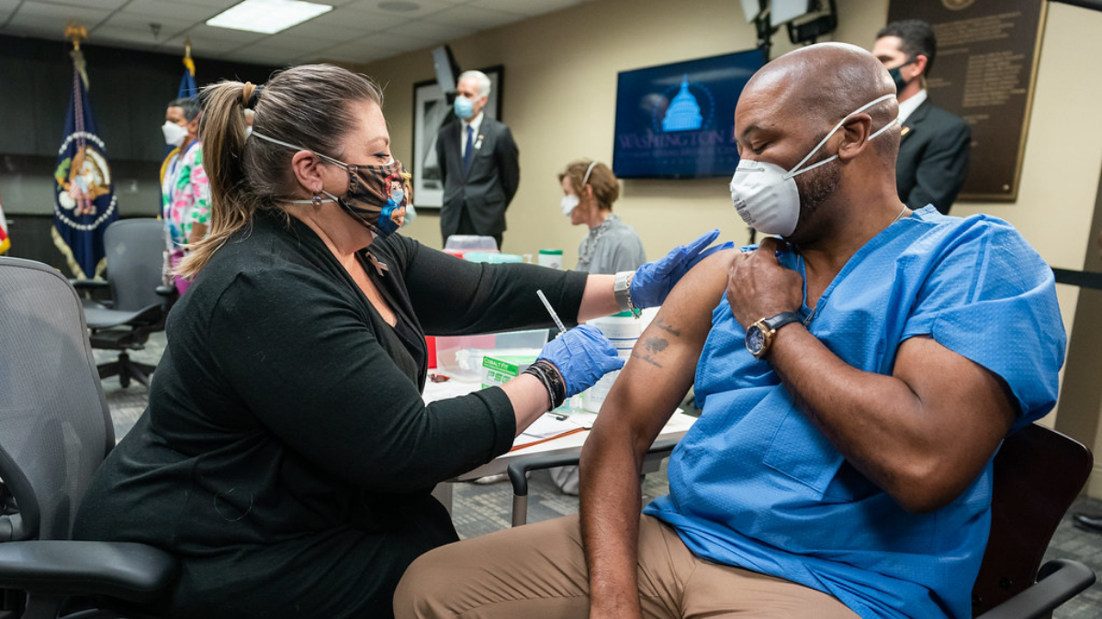

Reference: <https://www.snopes.com/fact-check/luciferase-covid-19-vaccines/?collection=379198>

<div style="display:relative; margin:0px; padding:0px"><img style="width: 1200px; height: 800px; margin:0px; padding:0px" src="**https://ohsu.ca1.qualtrics.com/CP/Graphic.php?IM=IM_cP8xyRvYcQ9fjqC"**></div>

<div style="position:relative; margin:0px; padding:0px; top:-8px; height:125px; width:100%; background-color:lightgray; padding:10px; font-weight:bold; font-size:1.3em">**The Moderna COVID-19 vaccine contains a bioluminescent marker called luciferase for tracking people**<img style="width: 25px; height: 25px;" src="https://ohsu.ca1.qualtrics.com/CP/Graphic.php?IM=IM_0pSmTtfRTtUtj3o"></div>

## 12

### Johnson & Johnson's COVID-19 vaccine contains aborted fetal cells

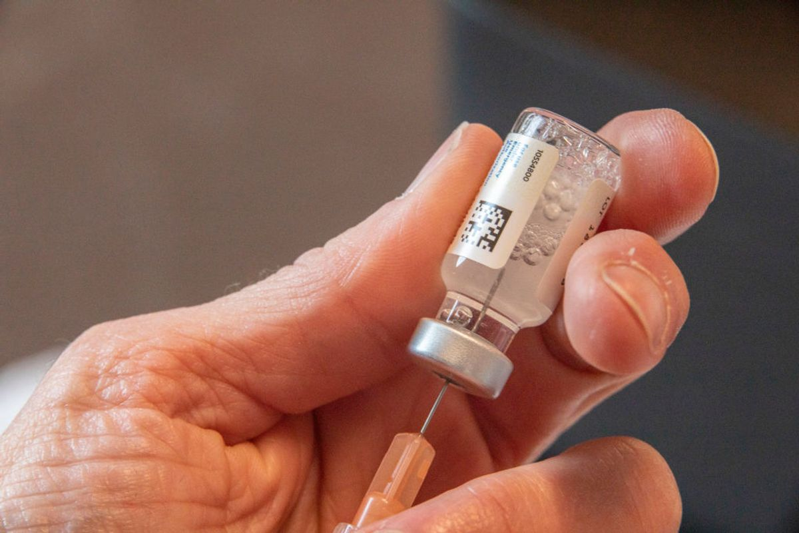

Reference: <https://www.snopes.com/fact-check/covid-vaccine-aborted-fetal-cells/?collection=379198>

<div style="display:relative; margin:0px; padding:0px"><img style="width: 1200px; height: 800px; margin:0px; padding:0px" src="**https://ohsu.ca1.qualtrics.com/CP/Graphic.php?IM=IM_aa78E7svFeM3kl8"**></div>

<div style="position:relative; margin:0px; padding:0px; top:-8px; height:100px; width:100%; background-color:lightgray; padding:10px; font-weight:bold; font-size:1.3em">**Johnson & Johnson's COVID-19 vaccine contains aborted fetal cells**<img style="width: 25px; height: 25px;" src="https://ohsu.ca1.qualtrics.com/CP/Graphic.php?IM=IM_0pSmTtfRTtUtj3o"></div>

## 13

### COVID-19 vaccines threaten people's fertility, no matter their type of reproductive systems

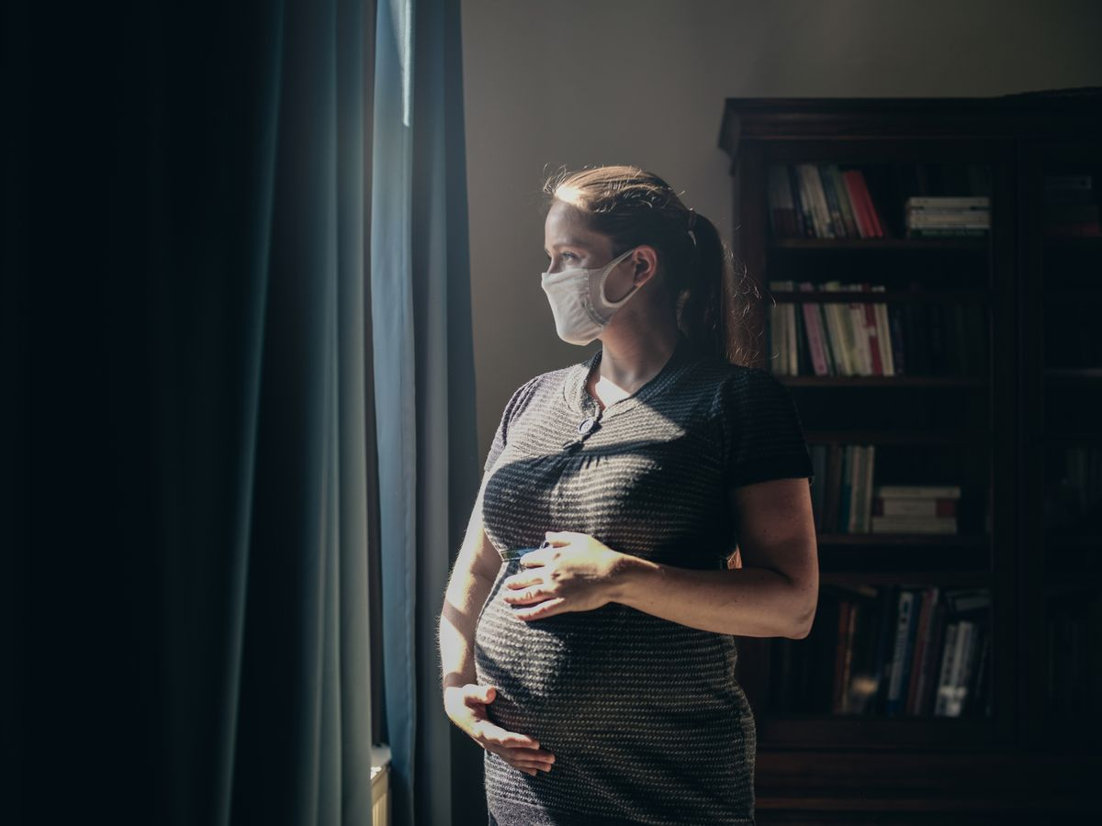

Reference: <https://www.snopes.com/fact-check/covid-vaccine-infertility/?collection=379198>

<div style="display:relative; margin:0px; padding:0px"><img style="width: 1200px; height: 800px; margin:0px; padding:0px" src="**https://ohsu.ca1.qualtrics.com/CP/Graphic.php?IM=IM_6Gvcmw1H0Bve7R4"**></div>

<div style="position:relative; margin:0px; padding:0px; top:-8px; height:100px; width:100%; background-color:lightgray; padding:10px; font-weight:bold; font-size:1.3em">**COVID-19 vaccines threaten people's fertility, no matter their type of reproductive systems**<img style="width: 25px; height: 25px;" src="https://ohsu.ca1.qualtrics.com/CP/Graphic.php?IM=IM_0pSmTtfRTtUtj3o"></div>

## 14

### COVID-19 vaccines change the color of human blood

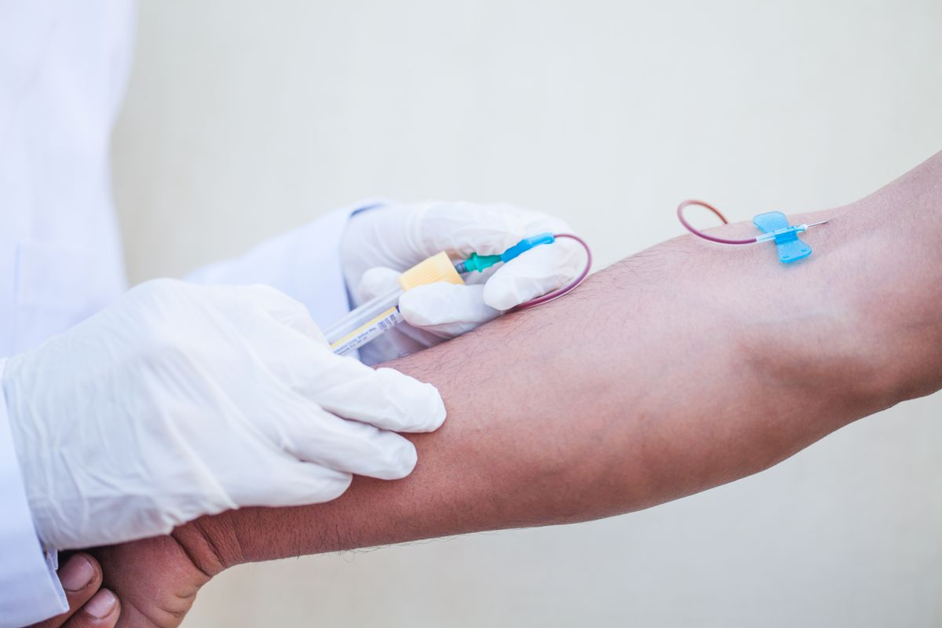

Reference: <https://www.snopes.com/fact-check/covid-19-vaccines-change-color-blood/?collection=379198>

<div style="display:relative; margin:0px; padding:0px"><img style="width: 1200px; height: 800px; margin:0px; padding:0px" src="**https://ohsu.ca1.qualtrics.com/CP/Graphic.php?IM=IM_6R9uJyDEp3ZwvK6"**></div>

<div style="position:relative; margin:0px; padding:0px; top:-8px; height:75px; width:100%; background-color:lightgray; padding:10px; font-weight:bold; font-size:1.3em">**COVID-19 vaccines change the color of human blood**<img style="width: 25px; height: 25px;" src="https://ohsu.ca1.qualtrics.com/CP/Graphic.php?IM=IM_0pSmTtfRTtUtj3o"></div>

## 15

### Pet scanner detects microchip from the COVID-19 vaccine in a person's arm

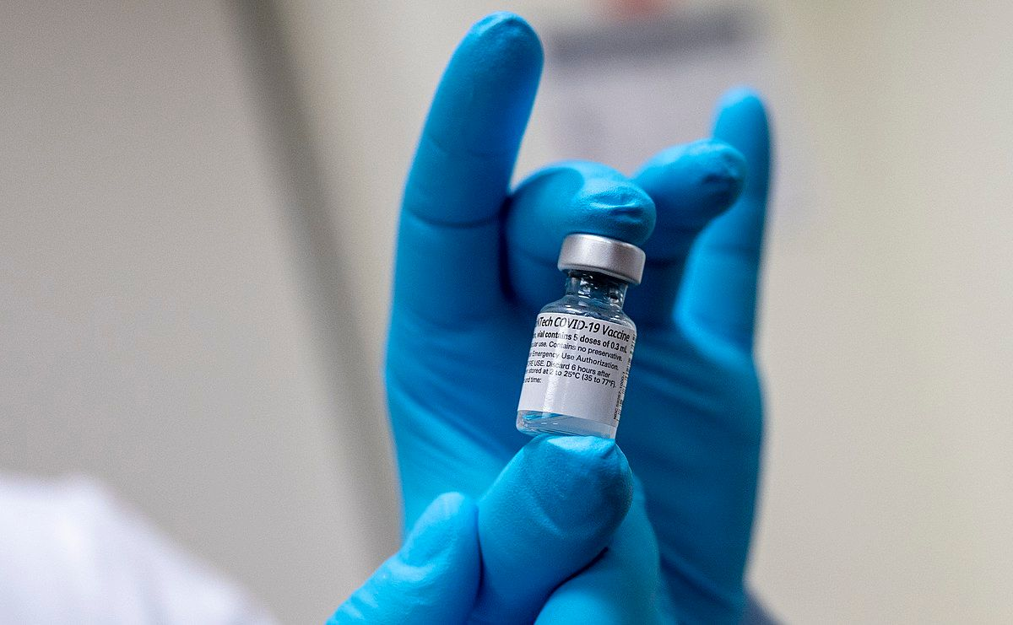

Reference: <https://www.snopes.com/fact-check/covid-vaccine-pet-microchip/?collection=379198>

<div style="display:relative; margin:0px; padding:0px"><img style="width: 1200px; height: 800px; margin:0px; padding:0px" src="**https://ohsu.ca1.qualtrics.com/CP/Graphic.php?IM=IM_6PDnCRPuIe7J1gG"**></div>

<div style="position:relative; margin:0px; padding:0px; top:-8px; height:100px; width:100%; background-color:lightgray; padding:10px; font-weight:bold; font-size:1.3em">**Pet scanner detects microchip from the COVID-19 vaccine in a person's arm**<img style="width: 25px; height: 25px;" src="https://ohsu.ca1.qualtrics.com/CP/Graphic.php?IM=IM_0pSmTtfRTtUtj3o"></div>

# “The Big Lie”

## 01

### Pennsylvania has 20,000 dead persons listed on its election rolls, which is evidence of massive voter fraud in 2020.

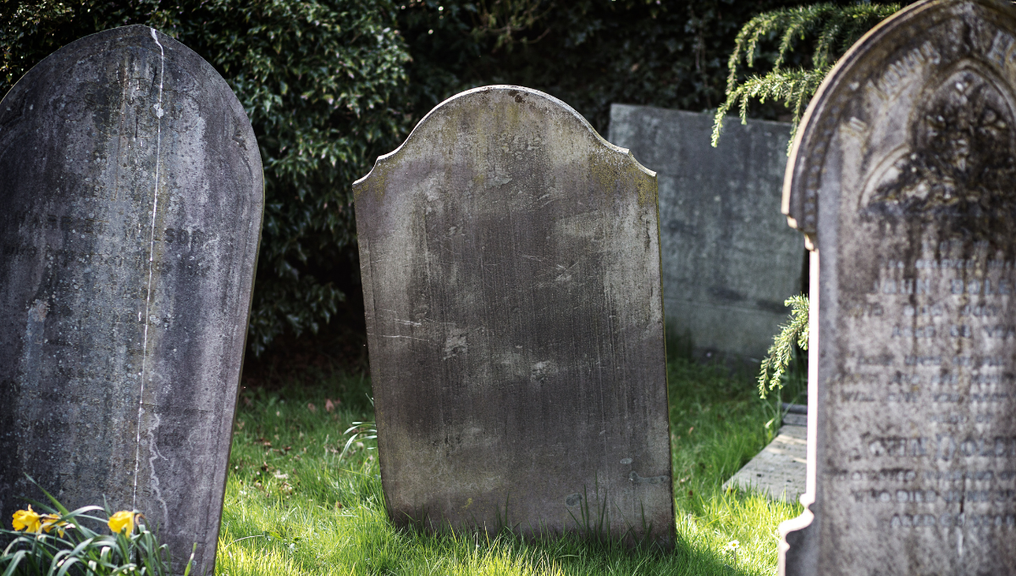

Reference: <https://www.snopes.com/fact-check/20000-dead-voters-in-pennsylvania/>

<div style="display:relative; margin:0px; padding:0px"><img style="width: 1200px; height: 800px; margin:0px; padding:0px" src="**https://ohsu.ca1.qualtrics.com/CP/Graphic.php?IM=IM_bC9H4xsKhuYdFsi"**></div>

<div style="position:relative; margin:0px; padding:0px; top:-8px; height:125px; width:100%; background-color:lightgray; padding:10px; font-weight:bold; font-size:1.3em">**Pennsylvania has 20,000 dead persons listed on its election rolls, which is evidence of massive voter fraud in 2020**<img style="width: 25px; height: 25px;" src="https://ohsu.ca1.qualtrics.com/CP/Graphic.php?IM=IM_0pSmTtfRTtUtj3o"></div>

## 02

### In the 2020 election, Wisconsin counted 3,239,920 votes but only has 3,129,000 registered voters.



Reference: <https://www.snopes.com/fact-check/wisconsin-more-votes-than-voters/>

<div style="display:relative; margin:0px; padding:0px"><img style="width: 1200px; height: 800px; margin:0px; padding:0px" src="**https://ohsu.ca1.qualtrics.com/CP/Graphic.php?IM=IM_9KBnDhDAtvlob0W"**></div>

<div style="position:relative; margin:0px; padding:0px; top:-8px; height:100px; width:100%; background-color:lightgray; padding:10px; font-weight:bold; font-size:1.3em">**In the 2020 election, Wisconsin counted 3,239,920 votes but only has 3,129,000 registered voters**<img style="width: 25px; height: 25px;" src="https://ohsu.ca1.qualtrics.com/CP/Graphic.php?IM=IM_0pSmTtfRTtUtj3o"></div>

## 03

### The Consent Decree signed by the Georgia Secretary of State, made it impossible to check and match signatures on 2020 election ballots

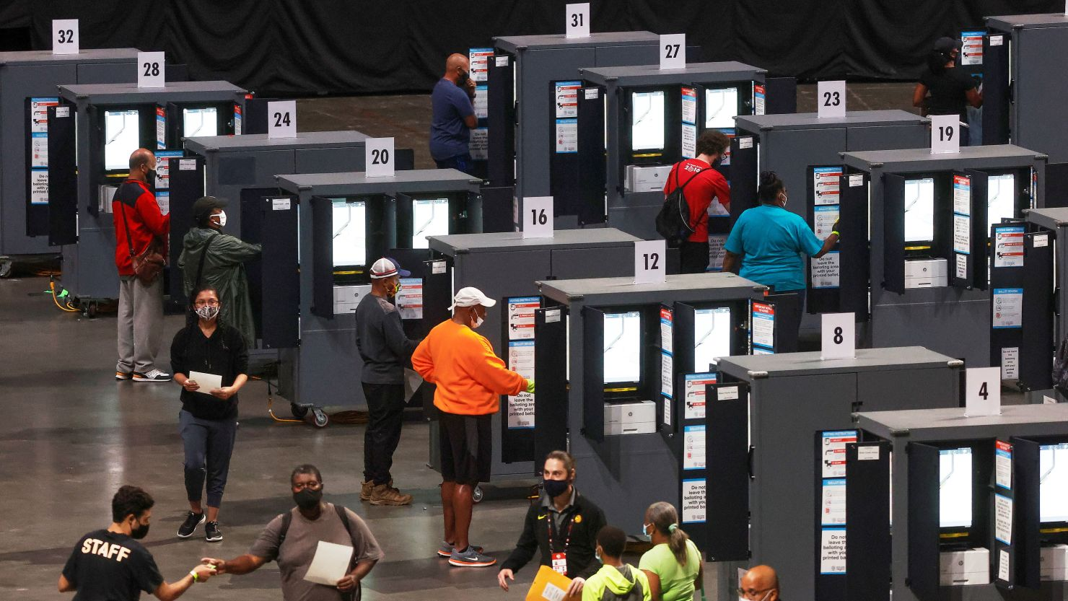

Headline Reference: <https://factba.se/trump/search#%22Must%2Bexpose%2Breal%2Bsignatures%22>

Image reference: <https://www.cnn.com/2023/06/20/politics/georgia-fulton-county-2020-elections-investigation/index.html>

<div style="display:relative; margin:0px; padding:0px"><img style="width: 1200px; height: 800px; margin:0px; padding:0px" src="**https://ohsu.ca1.qualtrics.com/CP/Graphic.php?IM=IM_t0vEUdivbw6FwLf"**></div>

<div style="position:relative; margin:0px; padding:0px; top:-8px; height:125px; width:100%; background-color:lightgray; padding:10px; font-weight:bold; font-size:1.3em">**The Consent Decree signed by the Georgia Secretary of State, made it impossible to check and match signatures on 2020 election ballots**<img style="width: 25px; height: 25px;" src="https://ohsu.ca1.qualtrics.com/CP/Graphic.php?IM=IM_0pSmTtfRTtUtj3o"></div>

## 04

### Over 250,000 ballots were dropped mysteriously into the rolls in Georgia

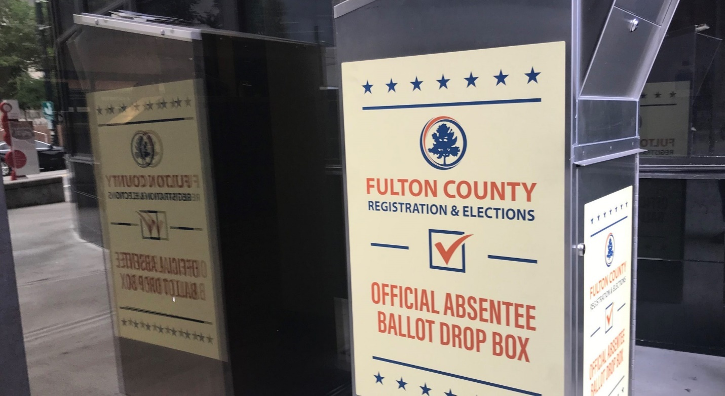

Headline reference: <https://www.cnn.com/2023/08/16/politics/fact-check-trump-georgia-indictment-lies/index.html>

Image reference: <https://www.wabe.org/absentee-ballot-drop-box-locations-in-atlanta/>

<div style="display:relative; margin:0px; padding:0px"><img style="width: 1200px; height: 800px; margin:0px; padding:0px" src="**https://ohsu.ca1.qualtrics.com/CP/Graphic.php?IM=IM_cat3cXarsVDzzhi "**></div>

<div style="position:relative; margin:0px; padding:0px; top:-8px; height:100px; width:100%; background-color:lightgray; padding:10px; font-weight:bold; font-size:1.3em">**Over 250,000 ballots were dropped mysteriously into the rolls in Georgia**<img style="width: 25px; height: 25px;" src="https://ohsu.ca1.qualtrics.com/CP/Graphic.php?IM=IM_0pSmTtfRTtUtj3o"></div>

## 05

### Georgia had "no way to verify" its 2020 presidential election results because Fulton County doesn't have digital images of ballots

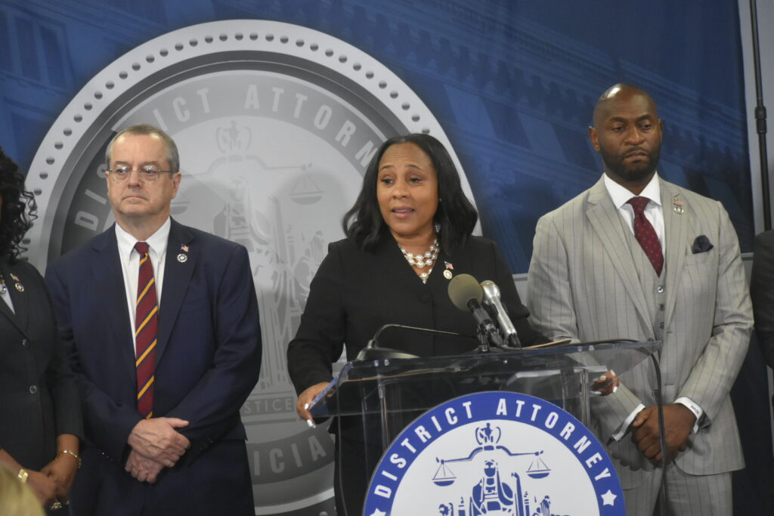

Headline reference: <https://www.snopes.com/fact-check/georgia-verify-2020-election/>

Image reference: <https://georgiarecorder.com/brief/eastman-other-defendants-in-fulton-2020-election-probe-start-to-surrender-at-county-jail/>

<div style="display:relative; margin:0px; padding:0px"><img style="width: 1200px; height: 800px; margin:0px; padding:0px" src="**https://ohsu.ca1.qualtrics.com/CP/Graphic.php?IM=IM_uxPoWtJ1OVaiwoa"**></div>

<div style="position:relative; margin:0px; padding:0px; top:-8px; height:125px; width:100%; background-color:lightgray; padding:10px; font-weight:bold; font-size:1.3em">**Georgia had "no way to verify" its 2020 presidential election results because Fulton County doesn't have digital images of ballots**<img style="width: 25px; height: 25px;" src="https://ohsu.ca1.qualtrics.com/CP/Graphic.php?IM=IM_0pSmTtfRTtUtj3o"></div>

## 06

### The U.S. Constitution specifies that a criminal conviction for insurrection is needed to disqualify a candidate from state or federal office

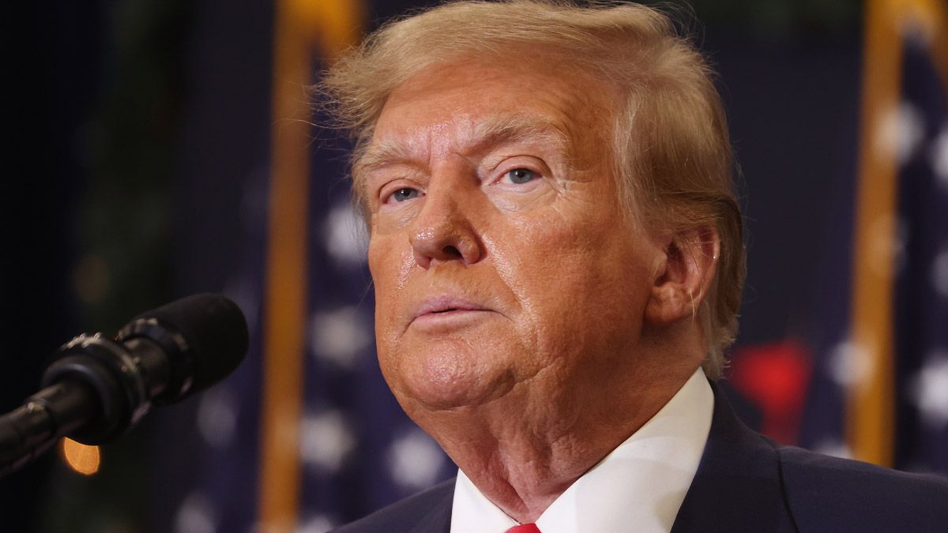

Reference: <https://www.snopes.com/fact-check/trump-criminal-conviction-ballot/>

<div style="display:relative; margin:0px; padding:0px"><img style="width: 1200px; height: 800px; margin:0px; padding:0px" src="**https://ohsu.ca1.qualtrics.com/CP/Graphic.php?IM=IM_TnXOXF5q8ogMiyN"**></div>

<div style="position:relative; margin:0px; padding:0px; top:-8px; height:125px; width:100%; background-color:lightgray; padding:10px; font-weight:bold; font-size:1.3em">**The U.S. Constitution specifies that a criminal conviction for insurrection is needed to disqualify a candidate from state or federal office** <img style="width: 25px; height: 25px;" src="https://ohsu.ca1.qualtrics.com/CP/Graphic.php?IM=IM_0pSmTtfRTtUtj3o"></div>

## 07

### Johnson, Speaker of the U.S. House of Representatives, is disqualified from running for Congress in 2024 due to a violation of the Fourteenth Amendment

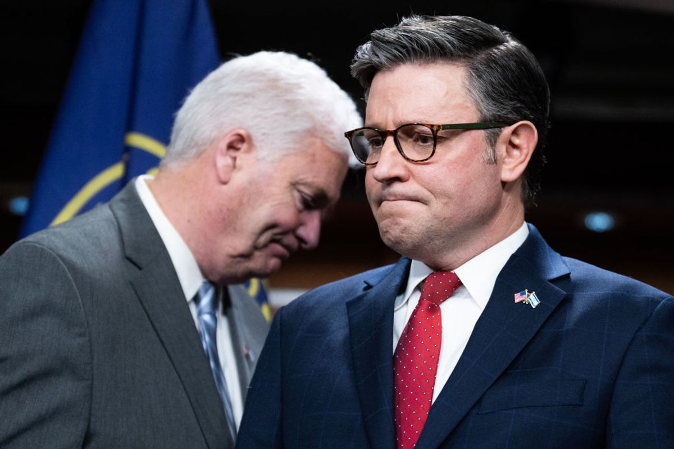

Reference: <https://www.snopes.com/news/2023/11/14/mike-johnson-disqualified/>

<div style="display:relative; margin:0px; padding:0px"><img style="width: 1200px; height: 800px; margin:0px; padding:0px" src="**https://ohsu.ca1.qualtrics.com/CP/Graphic.php?IM=IM_K6kLU81yNw2zFHJ"**></div>

<div style="position:relative; margin:0px; padding:0px; top:-8px; height:125px; width:100%; background-color:lightgray; padding:10px; font-weight:bold; font-size:1.3em">**Johnson, Speaker of the U.S. House of Representatives, is disqualified from running for Congress in 2024 due to a violation of the Fourteenth Amendment**<img style="width: 25px; height: 25px;" src="https://ohsu.ca1.qualtrics.com/CP/Graphic.php?IM=IM_0pSmTtfRTtUtj3o"></div>

## 08

### Freedom of Information Act requests show a dozen calls between the cellphone of Arizona Trump supporter Ray Epps and the office of then-U.S. House Speaker Nancy Pelosi in the week before the Jan. 6 attack on the U.S. Capitol

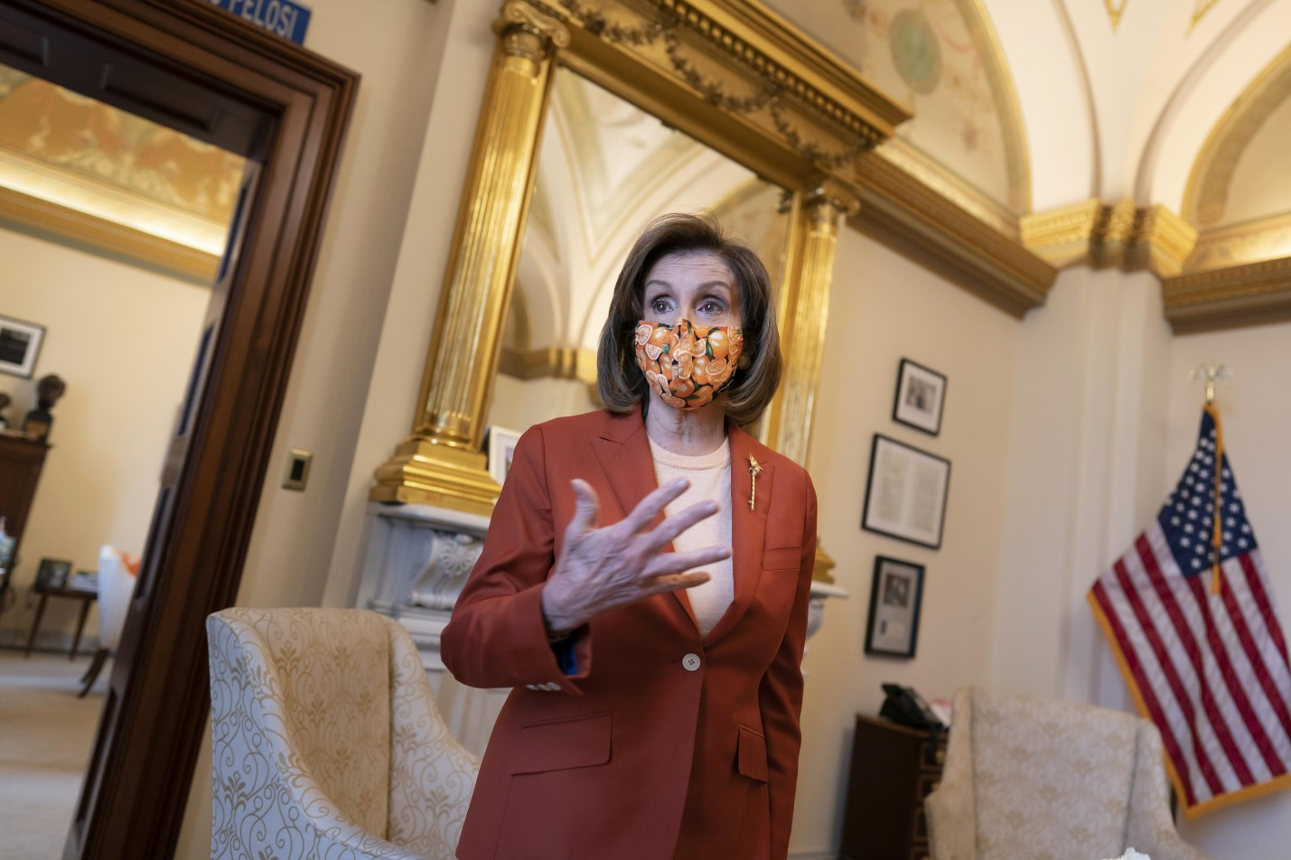

Headline reference: <https://www.snopes.com/fact-check/nancy-pelosi-ray-epps-phone-jan-6/>

Image reference: <https://apnews.com/article/russia-ukraine-science-social-media-53012d0ba8ea5545737a07b606b0c603>

<div style="display:relative; margin:0px; padding:0px"><img style="width: 1200px; height: 800px; margin:0px; padding:0px" src="**https://ohsu.ca1.qualtrics.com/CP/Graphic.php?IM=IM_xsceZoNxNH3ewsQ"**></div>

<div style="position:relative; margin:0px; padding:0px; top:-8px; height:190px; width:100%; background-color:lightgray; padding:10px; font-weight:bold; font-size:1.3em">**Freedom of Information Act requests show a dozen calls between the cellphone of Arizona Trump supporter Ray Epps and the office of then-U.S. House Speaker Nancy Pelosi in the week before the Jan. 6 attack on the U.S. Capitol**<img style="width: 25px; height: 25px;" src="https://ohsu.ca1.qualtrics.com/CP/Graphic.php?IM=IM_0pSmTtfRTtUtj3o"></div>

## 09

### Tucker Carlson revealed credible evidence of widespread voter fraud in Georgia

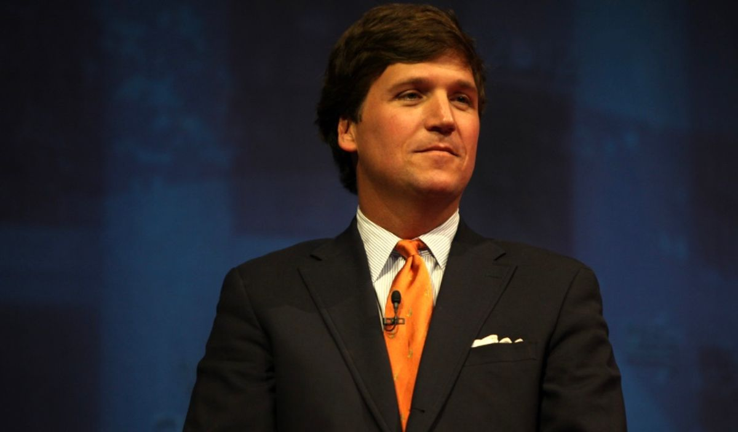

Reference: <https://www.snopes.com/fact-check/tucker-carlson-georgia-voter-fraud/>

<div style="display:relative; margin:0px; padding:0px"><img style="width: 1200px; height: 800px; margin:0px; padding:0px" src="**https://ohsu.ca1.qualtrics.com/CP/Graphic.php?IM=IM_68Hpq6dbrcPhXEF"**></div>

<div style="position:relative; margin:0px; padding:0px; top:-8px; height:100px; width:100%; background-color:lightgray; padding:10px; font-weight:bold; font-size:1.3em">**Tucker Carlson revealed credible evidence of widespread voter fraud in Georgia**<img style="width: 25px; height: 25px;" src="https://ohsu.ca1.qualtrics.com/CP/Graphic.php?IM=IM_0pSmTtfRTtUtj3o"></div>

## 10

### As many as 2,560 felons with an uncompleted sentence voted in Georgia’s 2020 Presidential Election

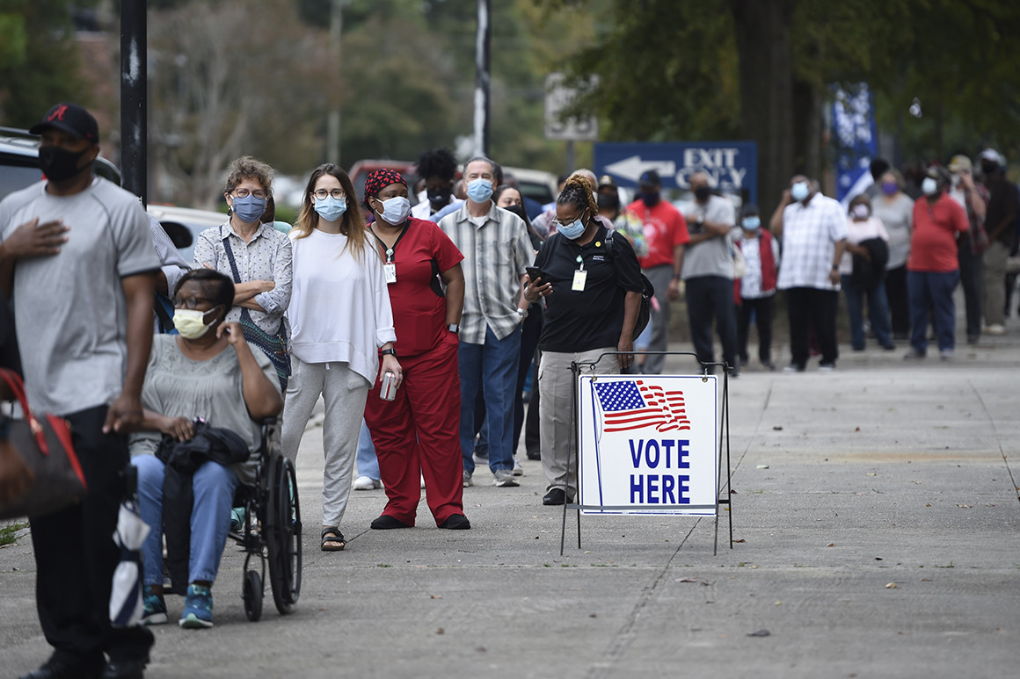

Headline reference: <https://www.cnn.com/2023/08/16/politics/fact-check-trump-georgia-indictment-lies/index.html> (#15)

Image reference: <https://www.politico.com/news/2020/10/26/georgia-voter-suppression-black-turnout-432405>

<div style="display:relative; margin:0px; padding:0px"><img style="width: 1200px; height: 800px; margin:0px; padding:0px" src="**https://ohsu.ca1.qualtrics.com/CP/Graphic.php?IM=IM_WJbvHIBQmIwiECJ"**></div>

<div style="position:relative; margin:0px; padding:0px; top:-8px; height:100px; width:100%; background-color:lightgray; padding:10px; font-weight:bold; font-size:1.3em">**As many as 2,560 felons with an uncompleted sentence voted in Georgia’s 2020 Presidential Election**<img style="width: 25px; height: 25px;" src="https://ohsu.ca1.qualtrics.com/CP/Graphic.php?IM=IM_0pSmTtfRTtUtj3o"></div>

## 11

### Georgia had at least 66,247 underage voters in the 2020 Election

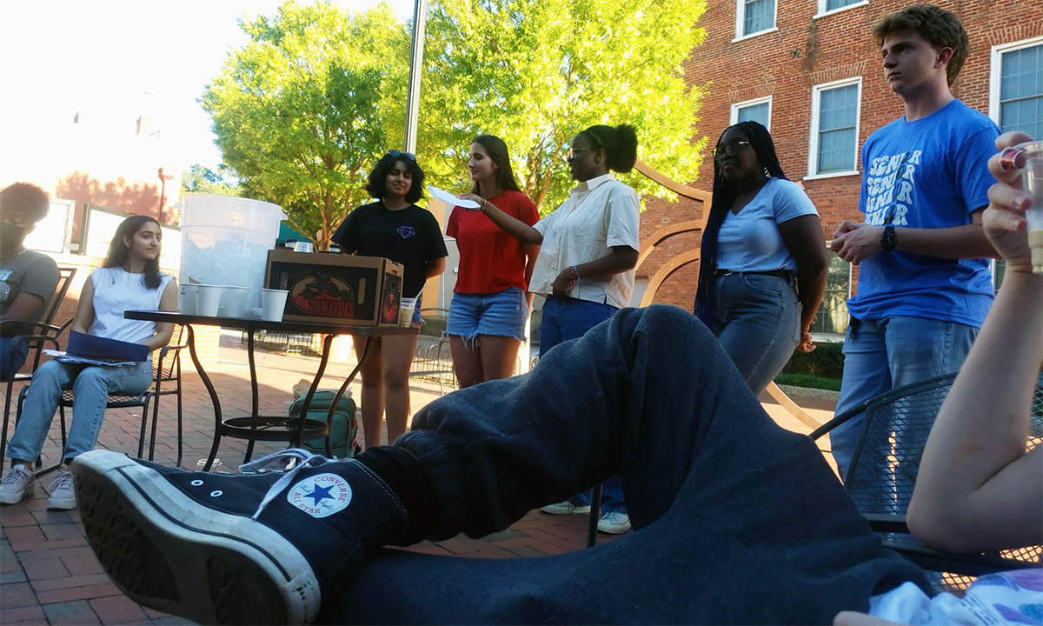

Headline reference: <https://www.cnn.com/2023/08/16/politics/fact-check-trump-georgia-indictment-lies/index.html> (#16)

Image reference: <https://www.the74million.org/article/georgias-youth-became-a-political-force-will-it-last/>

<div style="display:relative; margin:0px; padding:0px"><img style="width: 1200px; height: 800px; margin:0px; padding:0px" src="**https://ohsu.ca1.qualtrics.com/CP/Graphic.php?IM=IM_JZpXdyTxopMazSO"**></div>

<div style="position:relative; margin:0px; padding:0px; top:-8px; height:100px; width:100%; background-color:lightgray; padding:10px; font-weight:bold; font-size:1.3em">**Georgia had at least 66,247 underage voters in the 2020 Election**<img style="width: 25px; height: 25px;" src="https://ohsu.ca1.qualtrics.com/CP/Graphic.php?IM=IM_0pSmTtfRTtUtj3o"></div>

## 12

### States knew their certified vote totals were based on irregularities and fraud in 2020 Election

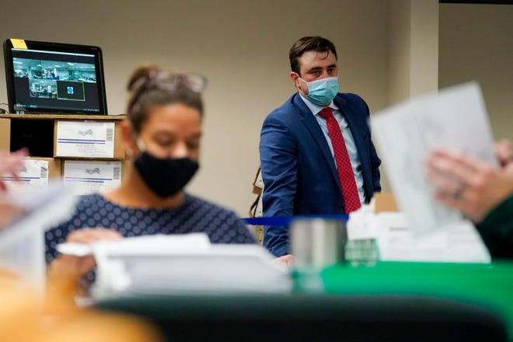

Headline reference: <https://www.cnn.com/2023/08/16/politics/fact-check-trump-georgia-indictment-lies/index.html> (#18)

Image reference: <https://www.usatoday.com/story/news/politics/elections/2020/11/10/no-2020-election-fraud-u-s-international-observers-report/6234390002/>

<div style="display:relative; margin:0px; padding:0px"><img style="width: 1200px; height: 800px; margin:0px; padding:0px" src="**https://ohsu.ca1.qualtrics.com/CP/Graphic.php?IM=IM_lcM68GUas8aUDLq"**></div>

<div style="position:relative; margin:0px; padding:0px; top:-8px; height:100px; width:100%; background-color:lightgray; padding:10px; font-weight:bold; font-size:1.3em">**States knew their certified vote totals were based on irregularities and fraud in 2020 Election**<img style="width: 25px; height: 25px;" src="https://ohsu.ca1.qualtrics.com/CP/Graphic.php?IM=IM_0pSmTtfRTtUtj3o"></div>

## 13

### In 2020 Election, Detroit’s results show 139% of the people voted

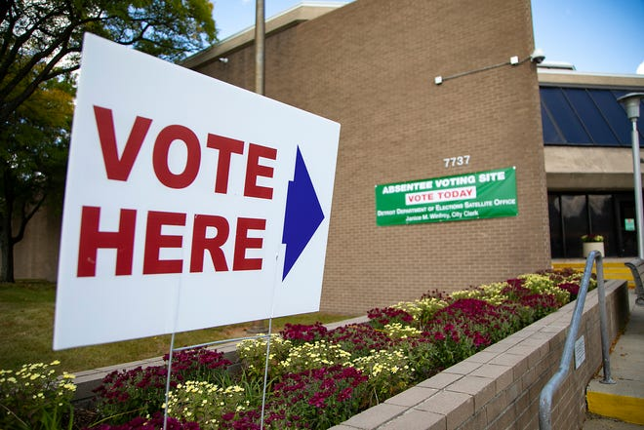

Headline reference: <https://www.cnn.com/2023/08/16/politics/fact-check-trump-georgia-indictment-lies/index.html> (#21)

Image reference: <https://www.freep.com/story/news/politics/elections/2020/11/03/detroit-early-voting-election-2020/6135167002/>

<div style="display:relative; margin:0px; padding:0px"><img style="width: 1200px; height: 800px; margin:0px; padding:0px" src="**https://ohsu.ca1.qualtrics.com/CP/Graphic.php?IM=IM_MyBCg3PZApY5sLq"**></div>

<div style="position:relative; margin:0px; padding:0px; top:-8px; height:100px; width:100%; background-color:lightgray; padding:10px; font-weight:bold; font-size:1.3em">**In 2020 Election, Detroit’s results show 139% of the people voted**<img style="width: 25px; height: 25px;" src="https://ohsu.ca1.qualtrics.com/CP/Graphic.php?IM=IM_0pSmTtfRTtUtj3o"></div>

## 14

### Trump was the real winner of the 2020 Election

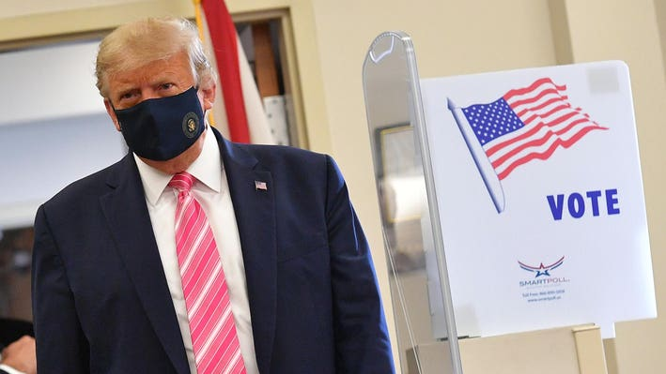

Headline reference: <https://www.cnn.com/2023/08/16/politics/fact-check-trump-georgia-indictment-lies/index.html> (#1)

Image reference: <https://www.forbes.com/sites/andrewsolender/2020/10/24/trump-votes-in-person-and-slams-mail-in-voting-as-campaign-urges-voters-to-vote-by-mail/?sh=2e7f0fda1ec1>

<div style="display:relative; margin:0px; padding:0px"><img style="width: 1200px; height: 800px; margin:0px; padding:0px" src="**https://ohsu.ca1.qualtrics.com/CP/Graphic.php?IM=IM_tvYVb3F6FfWk18M"**></div>

<div style="position:relative; margin:0px; padding:0px; top:-8px; height:75px; width:100%; background-color:lightgray; padding:10px; font-weight:bold; font-size:1.3em">**Trump was the real winner of the 2020 Election**<img style="width: 25px; height: 25px;" src="https://ohsu.ca1.qualtrics.com/CP/Graphic.php?IM=IM_0pSmTtfRTtUtj3o"></div>

## 15

### Close to 5,000 Georgia Ballots were cast in the names of deceased people in the 2020 Election

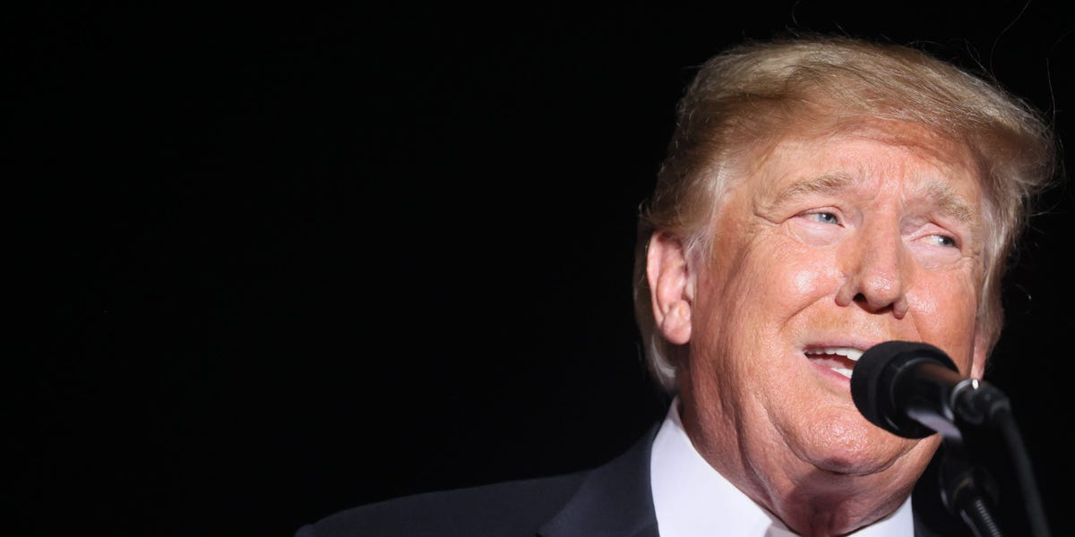

Headline reference: <https://www.cnn.com/2023/08/16/politics/fact-check-trump-georgia-indictment-lies/index.html> (#9)

Image reference: <https://www.businessinsider.com/trump-said-5000-dead-people-voted-georgia-only-4-cases-2021-12>

<div style="display:relative; margin:0px; padding:0px"><img style="width: 1200px; height: 800px; margin:0px; padding:0px" src="**https://ohsu.ca1.qualtrics.com/CP/Graphic.php?IM=IM_DqrTI8KSfEKBq6B"**></div>

<div style="position:relative; margin:0px; padding:0px; top:-8px; height:100px; width:100%; background-color:lightgray; padding:10px; font-weight:bold; font-size:1.3em">**Close to 5,000 Georgia Ballots were cast in the names of deceased people in the 2020 Election**<img style="width: 25px; height: 25px;" src="https://ohsu.ca1.qualtrics.com/CP/Graphic.php?IM=IM_0pSmTtfRTtUtj3o"></div>

# Real News

# Covid Vaccinations

## 01

### In 2023, the U.S. Federal Drug Administration updated existing guidelines to no longer authorize the use of monovalent Moderna and Pfizer-BioNTech COVID-19 vaccines

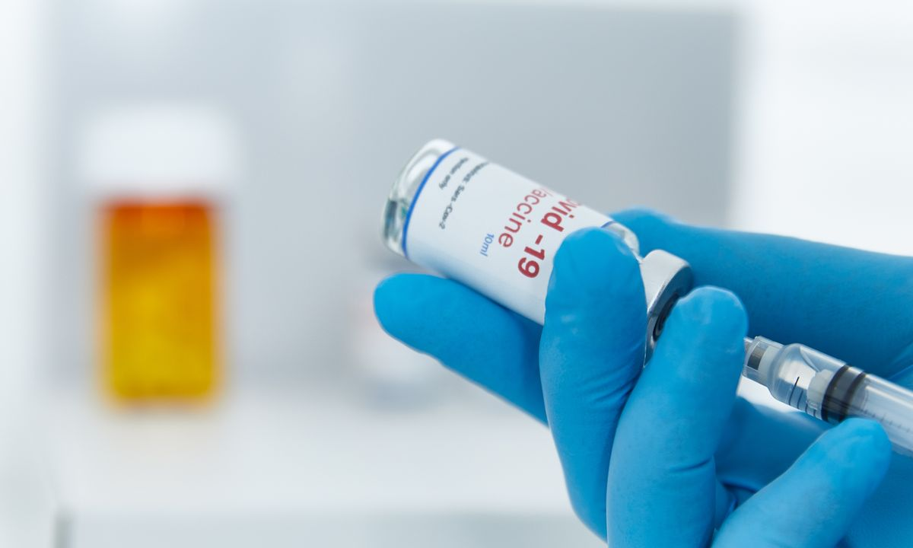

Reference: <https://www.snopes.com/fact-check/fda-covid-monovalent-vaccines/>

<div style="display:relative; margin:0px; padding:0px"><img style="width: 1200px; height: 800px; margin:0px; padding:0px" src="**https://ohsu.ca1.qualtrics.com/CP/Graphic.php?IM=IM_eFDUIJQOE6jsufV"**></div>

<div style="position:relative; margin:0px; padding:0px; top:-8px; height:150px; width:100%; background-color:lightgray; padding:10px; font-weight:bold; font-size:1.3em"> **In 2023, the U.S. Federal Drug Administration updated existing guidelines to no longer authorize the use of monovalent Moderna and Pfizer-BioNTech COVID-19 vaccines**<img style="width: 25px; height: 25px;" src="https://ohsu.ca1.qualtrics.com/CP/Graphic.php?IM=IM_0pSmTtfRTtUtj3o"></div>

## 02

### Lynette "Diamond" Hardaway’s Cause of Death Was Heart Disease, Not COVID-19 Vaccine

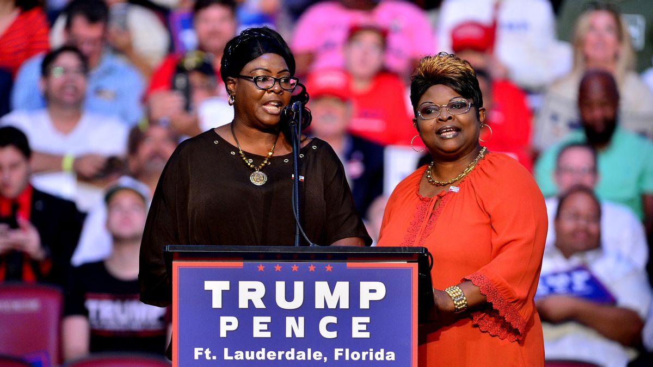

Reference: <https://www.snopes.com/news/2023/01/25/diamond-cause-of-death/>

<div style="display:relative; margin:0px; padding:0px"><img style="width: 1200px; height: 800px; margin:0px; padding:0px" src=" **https://ohsu.ca1.qualtrics.com/CP/Graphic.php?IM=IM_96npcbNxXYAYQe4"**></div>

<div style="position:relative; margin:0px; padding:0px; top:-8px; height:100px; width:100%; background-color:lightgray; padding:10px; font-weight:bold; font-size:1.3em">**Lynette "Diamond" Hardaway’s cause of death was heart disease, not COVID-19 vaccine**<img style="width: 25px; height: 25px;" src="https://ohsu.ca1.qualtrics.com/CP/Graphic.php?IM=IM_0pSmTtfRTtUtj3o"></div>

## 03

### The Lee County (Florida) Republican Party passed a proposal seeking to ban the sale and distribution of COVID-19 vaccines in Florida

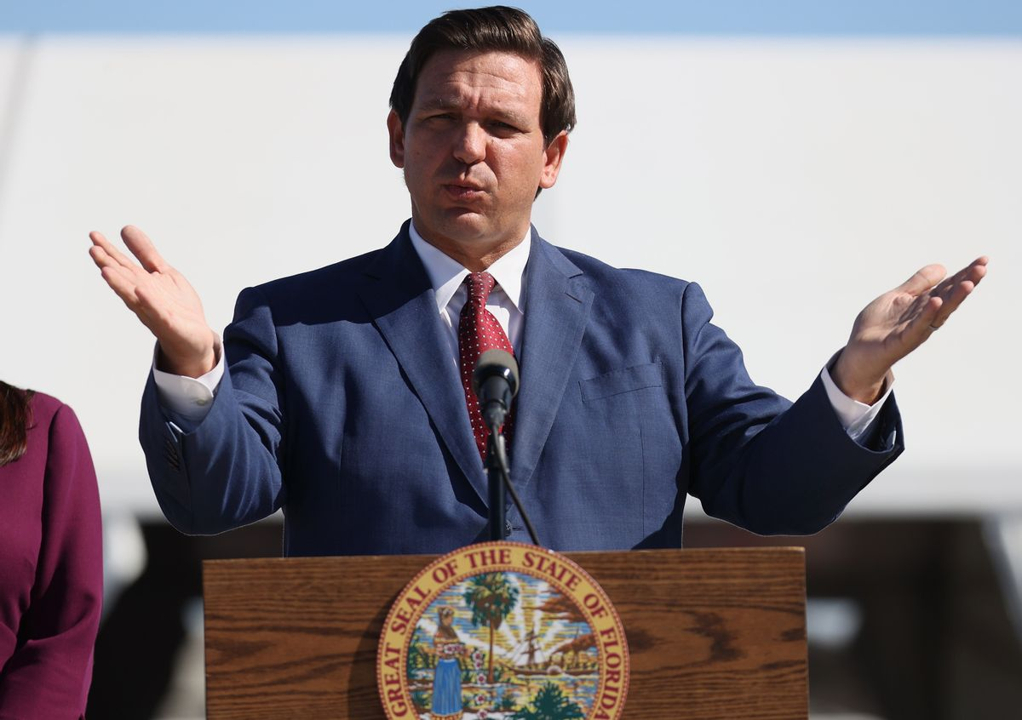

Reference: <https://www.snopes.com/fact-check/lee-county-covid-vax/>

<div style="display:relative; margin:0px; padding:0px"><img style="width: 1200px; height: 800px; margin:0px; padding:0px" src="**https://ohsu.ca1.qualtrics.com/CP/Graphic.php?IM=IM_JoaXE4ptz1Gkbj0"**></div>

<div style="position:relative; margin:0px; padding:0px; top:-8px; height:125px; width:100%; background-color:lightgray; padding:10px; font-weight:bold; font-size:1.3em">**The Lee County (Florida) Republican Party passed a proposal seeking to ban the sale and distribution of COVID-19 vaccines in Florida**<img style="width: 25px; height: 25px;" src="https://ohsu.ca1.qualtrics.com/CP/Graphic.php?IM=IM_0pSmTtfRTtUtj3o"></div>

## 04

### Former U.S. President Donald Trump released a statement saying that he hopes "everyone remembers" that he was responsible for the "beautiful" COVID-19 vaccine shot

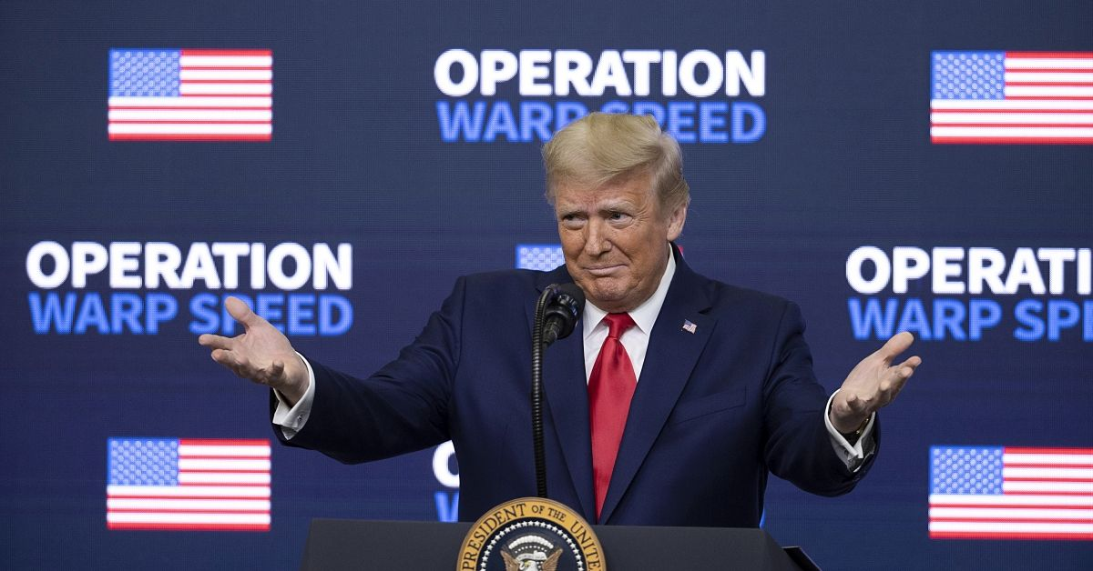

Reference: <https://www.snopes.com/fact-check/trump-beautiful-covid-19-vaccine/>

<div style="display:relative; margin:0px; padding:0px"><img style="width: 1200px; height: 800px; margin:0px; padding:0px" src="**https://ohsu.ca1.qualtrics.com/CP/Graphic.php?IM=IM_tNartHkT5ZmeRMJ"**></div>

<div style="position:relative; margin:0px; padding:0px; top:-8px; height:150px; width:100%; background-color:lightgray; padding:10px; font-weight:bold; font-size:1.3em">**Former U.S. President Donald Trump released a statement saying that he hopes "everyone remembers" that he was responsible for the "beautiful" COVID-19 vaccine shot**<img style="width: 25px; height: 25px;" src="https://ohsu.ca1.qualtrics.com/CP/Graphic.php?IM=IM_0pSmTtfRTtUtj3o"></div>

## 05

### Receiving multidose vaccinations in both arms, instead of just one, may increase the immune response, new research suggests

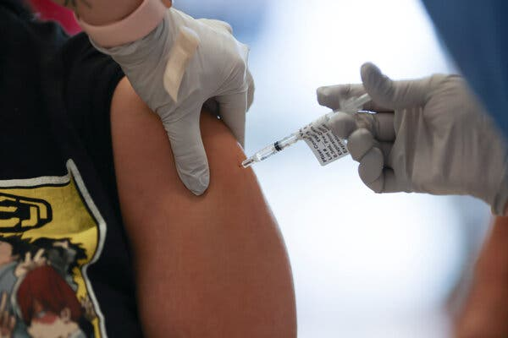

Reference: <https://www.nytimes.com/2024/02/06/health/vaccines-arms-immunity.html>

<div style="display:relative; margin:0px; padding:0px"><img style="width: 1200px; height: 800px; margin:0px; padding:0px" src="**https://ohsu.ca1.qualtrics.com/CP/Graphic.php?IM=IM_ZpJu3TIi2MoN7Yi"**></div>

<div style="position:relative; margin:0px; padding:0px; top:-8px; height:125px; width:100%; background-color:lightgray; padding:10px; font-weight:bold; font-size:1.3em">**Receiving multidose vaccinations in both arms, instead of just one, may increase the immune response, new research suggests**<img style="width: 25px; height: 25px;" src="https://ohsu.ca1.qualtrics.com/CP/Graphic.php?IM=IM_0pSmTtfRTtUtj3o"></div>

## 06

### COVID vaccine rollout issues largely fixed, insurers tell US health agency

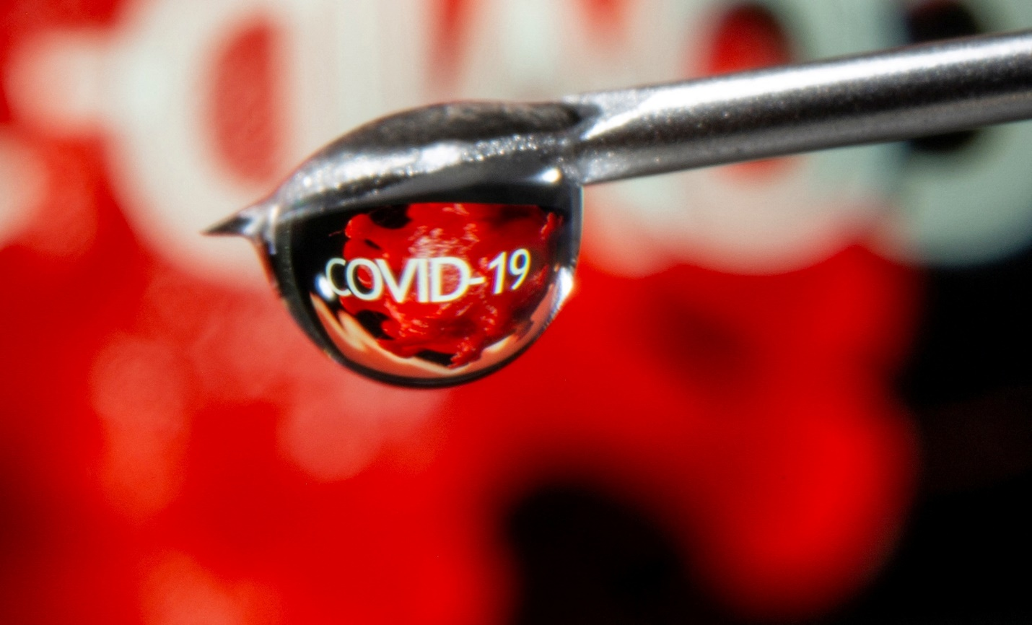

Reference: <https://www.reuters.com/business/healthcare-pharmaceuticals/covid-vaccine-rollout-issues-largely-fixed-insurers-tell-us-health-agency-2023-09-27/>

<div style="display:relative; margin:0px; padding:0px"><img style="width: 1200px; height: 800px; margin:0px; padding:0px" src="**https://ohsu.ca1.qualtrics.com/CP/Graphic.php?IM=IM_Ap2hQQaAhXIMDzX"**></div>

<div style="position:relative; margin:0px; padding:0px; top:-8px; height:100px; width:100%; background-color:lightgray; padding:10px; font-weight:bold; font-size:1.3em">**COVID vaccine rollout issues largely fixed, insurers tell US health agency**<img style="width: 25px; height: 25px;" src="https://ohsu.ca1.qualtrics.com/CP/Graphic.php?IM=IM_0pSmTtfRTtUtj3o"></div>

## 07

### Missouri Supreme Court strikes down law against homelessness, COVID vaccine mandates

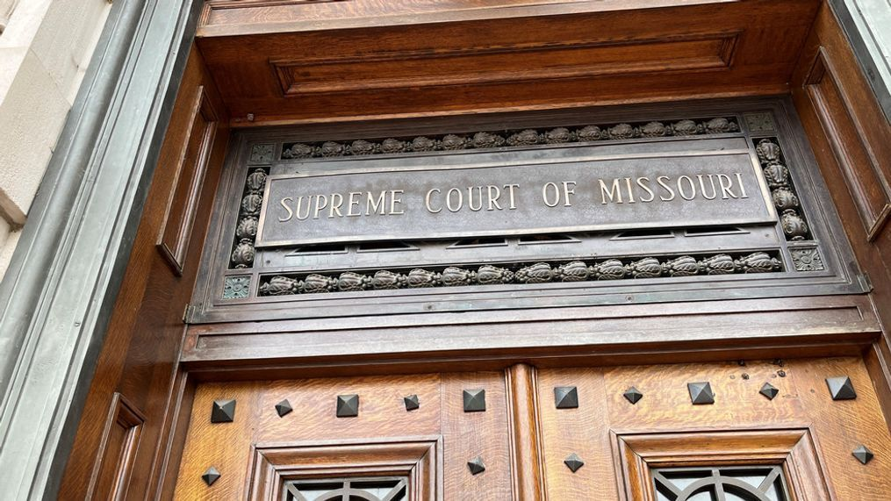

Reference: <https://apnews.com/article/homelessness-tents-crime-unhoused-2ccd7d12411cc0694b0030b38d9514fc>

<div style="display:relative; margin:0px; padding:0px"><img style="width: 1200px; height: 800px; margin:0px; padding:0px" src="**https://ohsu.ca1.qualtrics.com/CP/Graphic.php?IM=IM_jbLhsSx5sYVEWCt"**></div>

<div style="position:relative; margin:0px; padding:0px; top:-8px; height:100px; width:100%; background-color:lightgray; padding:10px; font-weight:bold; font-size:1.3em">**Missouri Supreme Court strikes down law against homelessness, COVID vaccine mandates**<img style="width: 25px; height: 25px;" src="https://ohsu.ca1.qualtrics.com/CP/Graphic.php?IM=IM_0pSmTtfRTtUtj3o"></div>

## 08

### Newest COVID shots are 54% effective in preventing symptoms, CDC finds

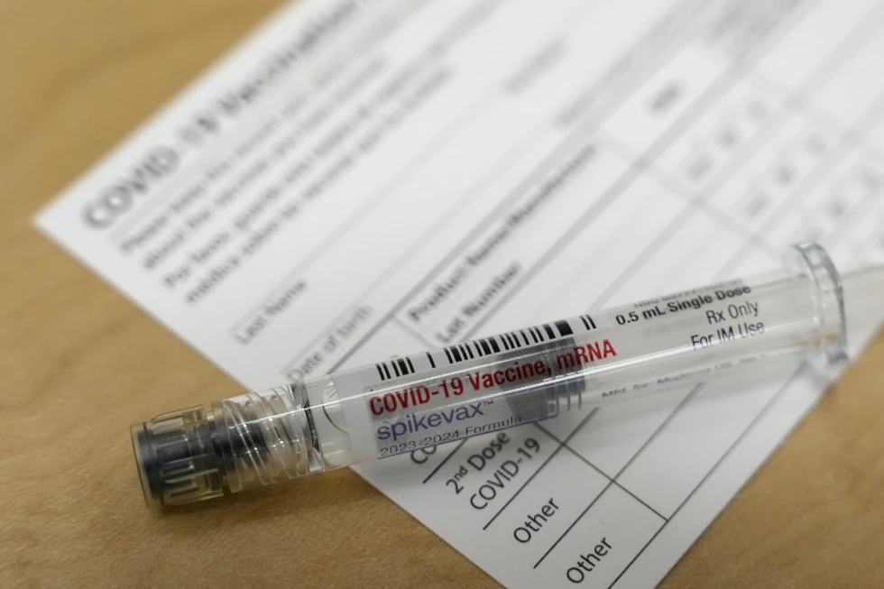

Reference: <https://apnews.com/article/covid19-vaccine-effectiveness-cdc-47a5a5466e95b65216bf2dc6db508a0f>

<div style="display:relative; margin:0px; padding:0px"><img style="width: 1200px; height: 800px; margin:0px; padding:0px" src="**https://ohsu.ca1.qualtrics.com/CP/Graphic.php?IM=IM_NUtCieeTlEOiuss"**></div>

<div style="position:relative; margin:0px; padding:0px; top:-8px; height:100px; width:100%; background-color:lightgray; padding:10px; font-weight:bold; font-size:1.3em">**Newest COVID shots are 54% effective in preventing symptoms, CDC finds**<img style="width: 25px; height: 25px;" src="https://ohsu.ca1.qualtrics.com/CP/Graphic.php?IM=IM_0pSmTtfRTtUtj3o"></div>

## 09

### Citing Misinformation, Florida Health Official Calls for Halt to Covid Vaccines

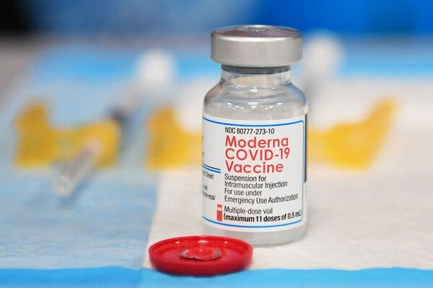

Reference: <https://www.nytimes.com/2024/01/03/health/covid-vaccines-florida.html>

<div style="display:relative; margin:0px; padding:0px"><img style="width: 1200px; height: 800px; margin:0px; padding:0px" src="**https://ohsu.ca1.qualtrics.com/CP/Graphic.php?IM=IM_z63ZqHck5cAZYVp"**></div>

<div style="position:relative; margin:0px; padding:0px; top:-8px; height:100px; width:100%; background-color:lightgray; padding:10px; font-weight:bold; font-size:1.3em">**Citing misinformation, Florida health official calls for halt to COVID vaccines**<img style="width: 25px; height: 25px;" src="https://ohsu.ca1.qualtrics.com/CP/Graphic.php?IM=IM_0pSmTtfRTtUtj3o"></div>

## 10

### Former West Virginia health official pleads guilty in COVID-19 payment investigation

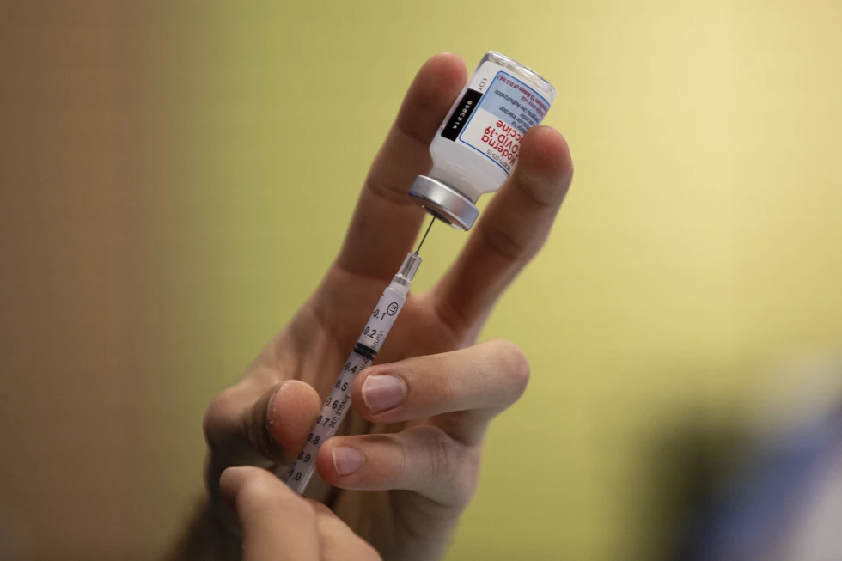

Reference: <https://apnews.com/article/west-virginia-covid19-priddy-guilty-30929c2b40f697906a259ffc9305057b>

<div style="display:relative; margin:0px; padding:0px"><img style="width: 1200px; height: 800px; margin:0px; padding:0px" src="**https://ohsu.ca1.qualtrics.com/CP/Graphic.php?IM=IM_DPJUwX0Eqh7uw9z"**></div>

<div style="position:relative; margin:0px; padding:0px; top:-8px; height:100px; width:100%; background-color:lightgray; padding:10px; font-weight:bold; font-size:1.3em">**Former West Virginia health official pleads guilty in COVID-19 payment investigation**<img style="width: 25px; height: 25px;" src="https://ohsu.ca1.qualtrics.com/CP/Graphic.php?IM=IM_0pSmTtfRTtUtj3o"></div>

## 11

### Not wearing a mask during COVID-19 health emergency isn’t a free speech right, court says

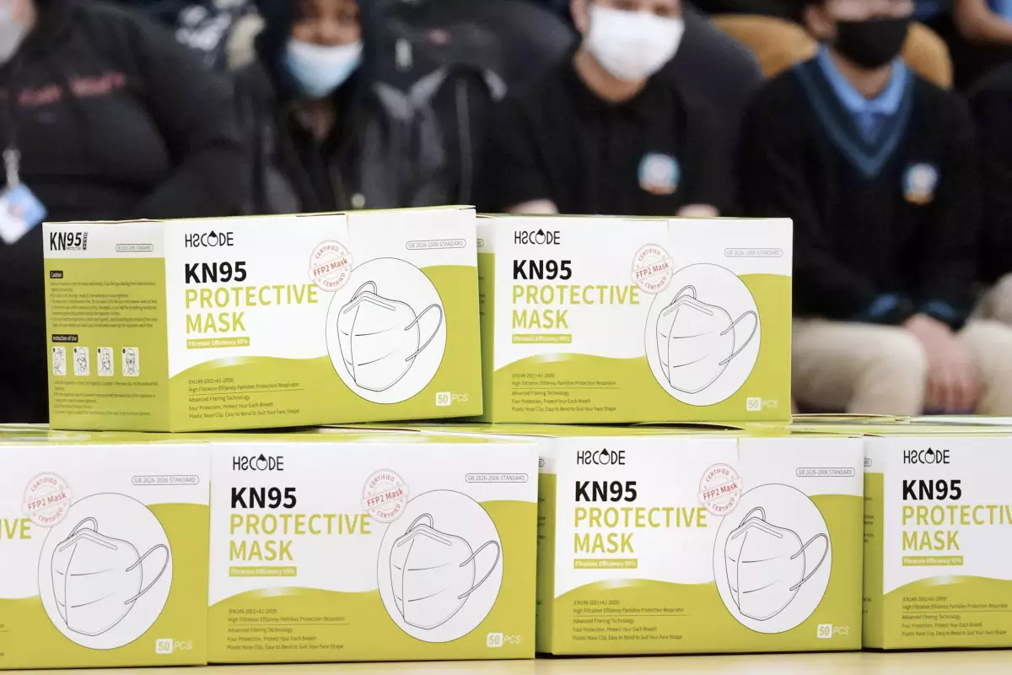

Reference: <https://www.latimes.com/world-nation/story/2024-02-06/not-wearing-a-mask-during-covid-19-health-emergency-isnt-a-free-speech-right-appeals-court-says>

<div style="display:relative; margin:0px; padding:0px"><img style="width: 1200px; height: 800px; margin:0px; padding:0px" src="**https://ohsu.ca1.qualtrics.com/CP/Graphic.php?IM=IM_tAj88c6cohEUQZV"**></div>

<div style="position:relative; margin:0px; padding:0px; top:-8px; height:100px; width:100%; background-color:lightgray; padding:10px; font-weight:bold; font-size:1.3em">**Not wearing a mask during COVID-19 health emergency isn’t a free speech right, court says**<img style="width: 25px; height: 25px;" src="https://ohsu.ca1.qualtrics.com/CP/Graphic.php?IM=IM_0pSmTtfRTtUtj3o"></div>

## 12

### Populations of wild deer across North America have tested positive for SARS-CoV-2 antibodies

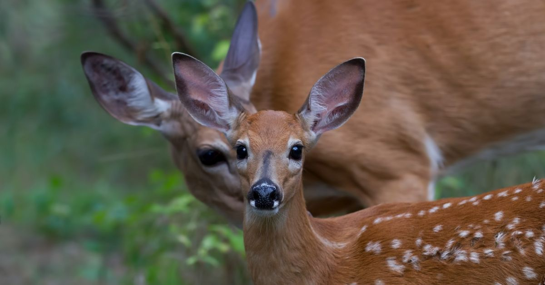

Reference: <https://www.snopes.com/fact-check/study-coronavirus-antibodies-deer/>

<div style="display:relative; margin:0px; padding:0px"><img style="width: 1200px; height: 800px; margin:0px; padding:0px" src="**https://ohsu.ca1.qualtrics.com/CP/Graphic.php?IM=IM_SyDy6ambsAnvs87"**></div>

<div style="position:relative; margin:0px; padding:0px; top:-8px; height:100px; width:100%; background-color:lightgray; padding:10px; font-weight:bold; font-size:1.3em">**Populations of wild deer across North America have tested positive for SARS-CoV-2 antibodies**<img style="width: 25px; height: 25px;" src="https://ohsu.ca1.qualtrics.com/CP/Graphic.php?IM=IM_0pSmTtfRTtUtj3o"></div>

## 13

### The Great Grift: How billions in COVID-19 relief aid was stolen or wasted

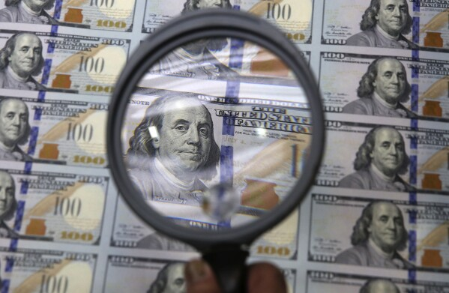

Reference: <https://apnews.com/article/pandemic-fraud-waste-billions-small-business-labor-fb1d9a9eb24857efbe4611344311ae78>

<div style="display:relative; margin:0px; padding:0px"><img style="width: 1200px; height: 800px; margin:0px; padding:0px" src="**https://ohsu.ca1.qualtrics.com/CP/Graphic.php?IM=IM_HNENbAaggdWAGd0"**></div>

<div style="position:relative; margin:0px; padding:0px; top:-8px; height:100px; width:100%; background-color:lightgray; padding:10px; font-weight:bold; font-size:1.3em">**The Great Grift: How billions in COVID-19 relief aid was stolen or wasted**<img style="width: 25px; height: 25px;" src="https://ohsu.ca1.qualtrics.com/CP/Graphic.php?IM=IM_0pSmTtfRTtUtj3o"></div>

## 14

### Long COVID affects more older adults; shots don’t prevent it

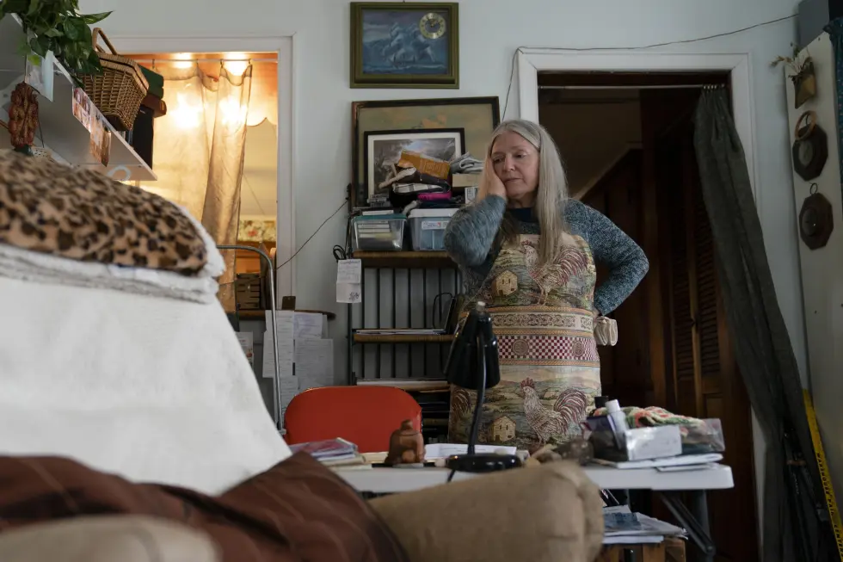

Reference: <https://apnews.com/article/long-covid-breakthrough-infections-e05e67c5bb12c18c594aaf5ec6dec954>

<div style="display:relative; margin:0px; padding:0px"><img style="width: 1200px; height: 800px; margin:0px; padding:0px" src="**https://ohsu.ca1.qualtrics.com/CP/Graphic.php?IM=IM_GWBVIqIaanVQIDY"**></div>

<div style="position:relative; margin:0px; padding:0px; top:-8px; height:100px; width:100%; background-color:lightgray; padding:10px; font-weight:bold; font-size:1.3em">**Long COVID affects more older adults; shots don’t prevent it**<img style="width: 25px; height: 25px;" src="https://ohsu.ca1.qualtrics.com/CP/Graphic.php?IM=IM_0pSmTtfRTtUtj3o"></div>

## 15

### COVID vaccines saved 20M lives in 1st year, scientists say

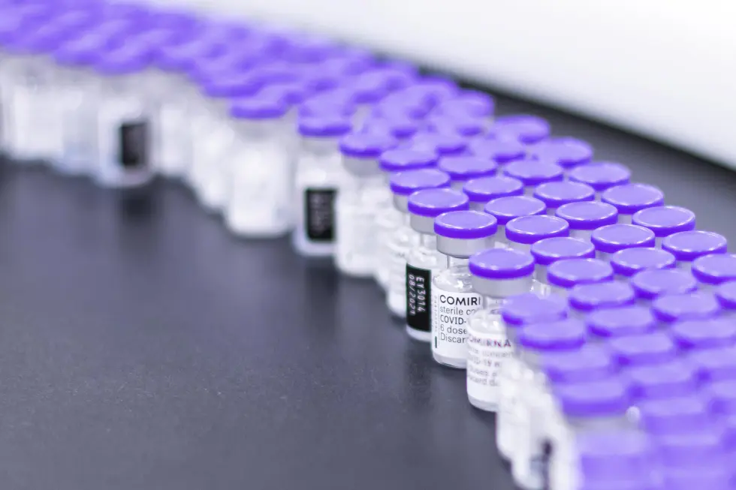

Reference: <https://apnews.com/article/covid-science-health-england-54d29ae3af5c700f15d704c14ee224b5>

<div style="display:relative; margin:0px; padding:0px"><img style="width: 1200px; height: 800px; margin:0px; padding:0px" src="**https://ohsu.ca1.qualtrics.com/CP/Graphic.php?IM=IM_Ke1bGVRP8aGr5ZX"**></div>

<div style="position:relative; margin:0px; padding:0px; top:-8px; height:100px; width:100%; background-color:lightgray; padding:10px; font-weight:bold; font-size:1.3em">**COVID vaccines saved 20M lives in 1st year, scientists say**<img style="width: 25px; height: 25px;" src="https://ohsu.ca1.qualtrics.com/CP/Graphic.php?IM=IM_0pSmTtfRTtUtj3o"></div>

# “The Big Lie”

## 01

### Rep. Hakeem Jeffries Describes a US Select Committee as a ‘Committee On Insurrection Protection’

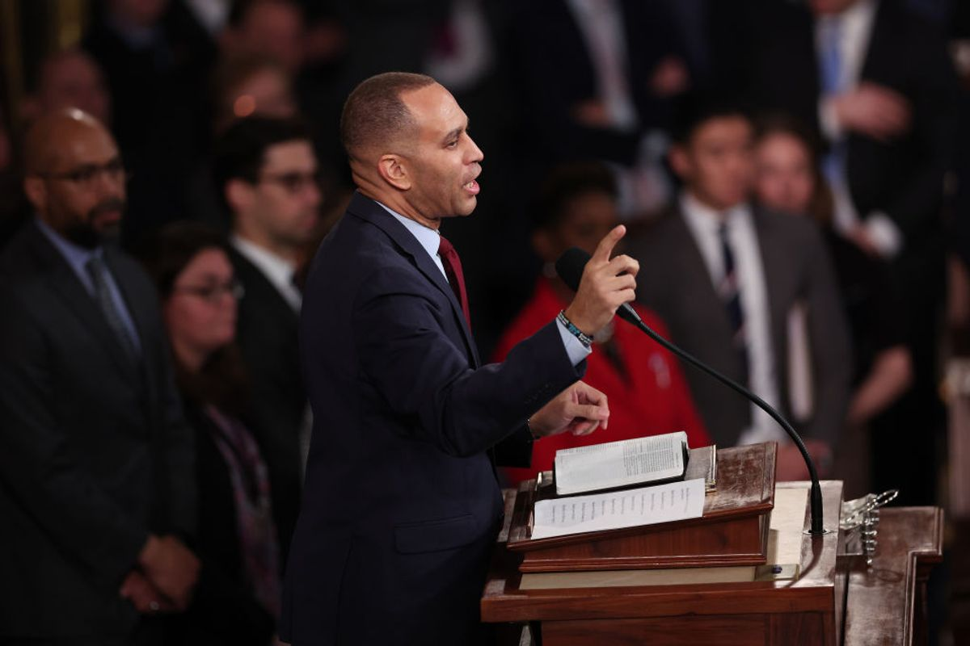

Reference: <https://www.snopes.com/fact-check/insurrection-protection-committee-hakeem-jeffries/>

<div style="display:relative; margin:0px; padding:0px"><img style="width: 1200px; height: 800px; margin:0px; padding:0px" src="**https://ohsu.ca1.qualtrics.com/CP/Graphic.php?IM=IM_7CQvKU9H3f9dWpm"**></div>

<div style="position:relative; margin:0px; padding:0px; top:-8px; height:100px; width:100%; background-color:lightgray; padding:10px; font-weight:bold; font-size:1.3em">**Rep. Hakeem Jeffries Describes a US Select Committee as a ‘Committee On Insurrection Protection’**<img style="width: 25px; height: 25px;" src="https://ohsu.ca1.qualtrics.com/CP/Graphic.php?IM=IM_0pSmTtfRTtUtj3o"></div>

## 02

### Kanye West's former publicist was one of the 19 people indicted in Georgia's 2020 election meddling case against Donald Trump

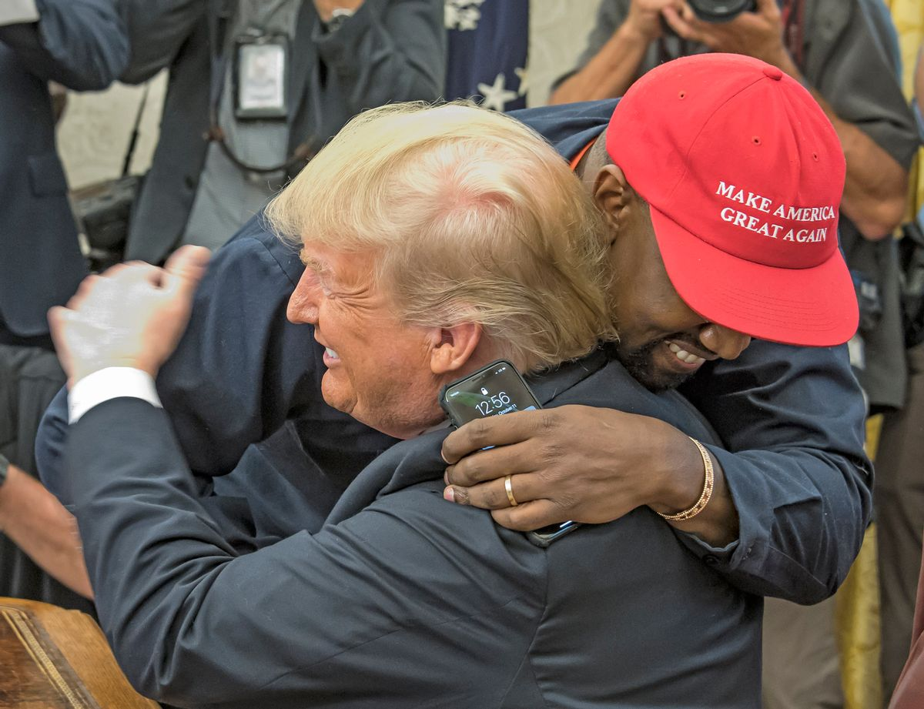

Reference: <https://www.snopes.com/fact-check/kanye-former-publicist-indicted/>

<div style="display:relative; margin:0px; padding:0px"><img style="width: 1200px; height: 800px; margin:0px; padding:0px" src="**https://ohsu.ca1.qualtrics.com/CP/Graphic.php?IM=IM_Uq1AJaCEIzFSAXf"**></div>

<div style="position:relative; margin:0px; padding:0px; top:-8px; height:125px; width:100%; background-color:lightgray; padding:10px; font-weight:bold; font-size:1.3em">**Kanye West's former publicist was one of the 19 people indicted in Georgia's 2020 election meddling case against Donald Trump**<img style="width: 25px; height: 25px;" src="https://ohsu.ca1.qualtrics.com/CP/Graphic.php?IM=IM_0pSmTtfRTtUtj3o"></div>

## 03

### Poll: Majority of Iowa GOP caucus-goers don’t believe Biden legitimately won in 2020

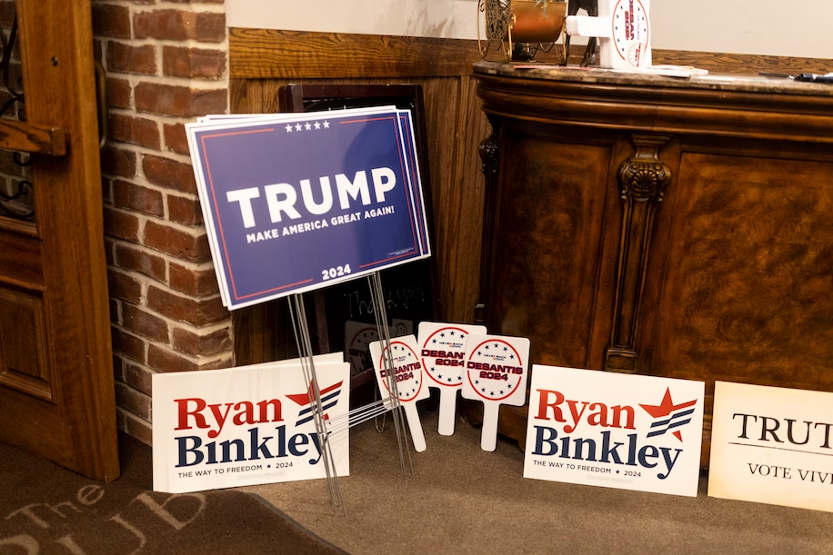

Reference: <https://www.washingtonpost.com/politics/2024/01/15/poll-majority-iowa-gop-caucus-goers-dont-believe-biden-legitimately-won-2020/>

<div style="display:relative; margin:0px; padding:0px"><img style="width: 1200px; height: 800px; margin:0px; padding:0px" src="**https://ohsu.ca1.qualtrics.com/CP/Graphic.php?IM=IM_dDS2vwTjR8N79OR"**></div>

<div style="position:relative; margin:0px; padding:0px; top:-8px; height:100px; width:100%; background-color:lightgray; padding:10px; font-weight:bold; font-size:1.3em"> **Poll: Majority of Iowa GOP caucus-goers don’t believe Biden legitimately won in 2020**<img style="width: 25px; height: 25px;" src="https://ohsu.ca1.qualtrics.com/CP/Graphic.php?IM=IM_0pSmTtfRTtUtj3o"></div>

## 04

### Illinois elections board dismisses effort to remove Trump from ballot

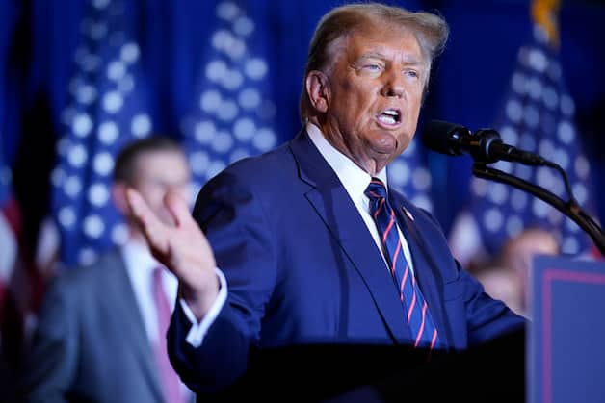

Reference: <https://www.washingtonpost.com/politics/2024/01/30/trump-illinois-primary-ballot/>

<div style="display:relative; margin:0px; padding:0px"><img style="width: 1200px; height: 800px; margin:0px; padding:0px" src="**https://ohsu.ca1.qualtrics.com/CP/Graphic.php?IM=IM_ghTPCgvyiK0ElgG"**></div>

<div style="position:relative; margin:0px; padding:0px; top:-8px; height:100px; width:100%; background-color:lightgray; padding:10px; font-weight:bold; font-size:1.3em">**Illinois elections board dismisses effort to remove Trump from ballot**<img style="width: 25px; height: 25px;" src="https://ohsu.ca1.qualtrics.com/CP/Graphic.php?IM=IM_0pSmTtfRTtUtj3o"></div>

## 05

### A 2022 Georgia voting law reduced ballot drop box access in places that used them most

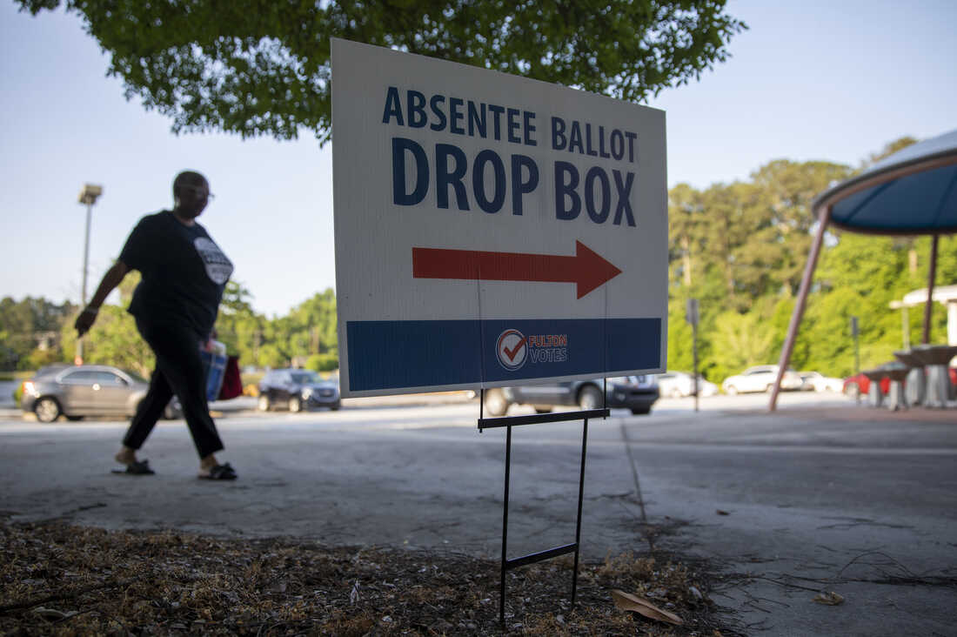

Reference: <https://www.npr.org/2022/07/27/1112487312/georgia-voting-law-ballot-drop-box-access>

<div style="display:relative; margin:0px; padding:0px"><img style="width: 1200px; height: 800px; margin:0px; padding:0px" src="**https://ohsu.ca1.qualtrics.com/CP/Graphic.php?IM=IM_uaNTenhXVH2QnBu"**></div>

<div style="position:relative; margin:0px; padding:0px; top:-8px; height:100px; width:100%; background-color:lightgray; padding:10px; font-weight:bold; font-size:1.3em">**A 2022 Georgia voting law reduced ballot drop box access in places that used them most**<img style="width: 25px; height: 25px;" src="https://ohsu.ca1.qualtrics.com/CP/Graphic.php?IM=IM_0pSmTtfRTtUtj3o"></div>

## 06

### The Trump campaign embraces Jan. 6 rioters with money and pardon promises

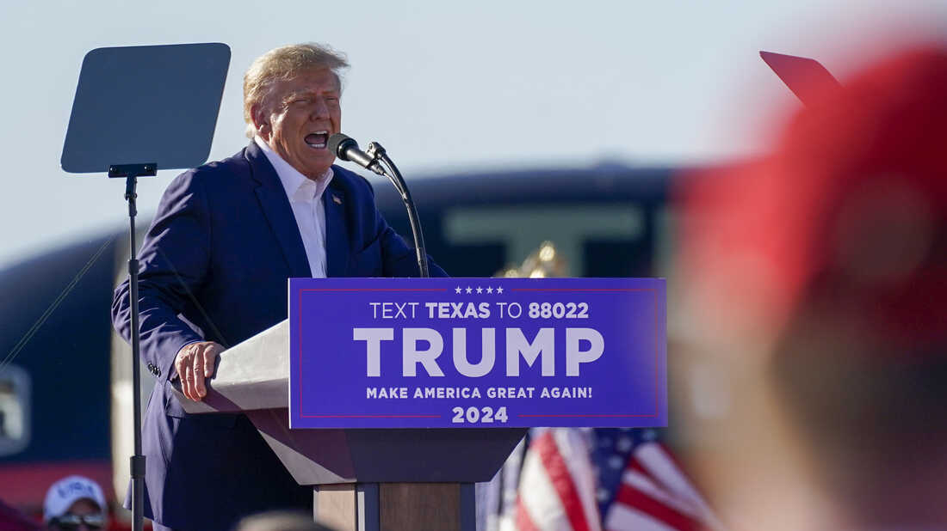

Reference: <https://www.npr.org/2024/01/04/1218672628/the-trump-campaign-embraces-jan-6-rioters-with-money-and-pardon-promises>

<div style="display:relative; margin:0px; padding:0px"><img style="width: 1200px; height: 800px; margin:0px; padding:0px" src="**https://ohsu.ca1.qualtrics.com/CP/Graphic.php?IM=IM_tNknOggtkaz44uy"**></div>

<div style="position:relative; margin:0px; padding:0px; top:-8px; height:100px; width:100%; background-color:lightgray; padding:10px; font-weight:bold; font-size:1.3em">**The Trump campaign embraces Jan. 6 rioters with money and pardon promises**<img style="width: 25px; height: 25px;" src="https://ohsu.ca1.qualtrics.com/CP/Graphic.php?IM=IM_0pSmTtfRTtUtj3o"></div>

## 07

### For election workers, Trump's lies have meant threats, harassment and a poisoned dog

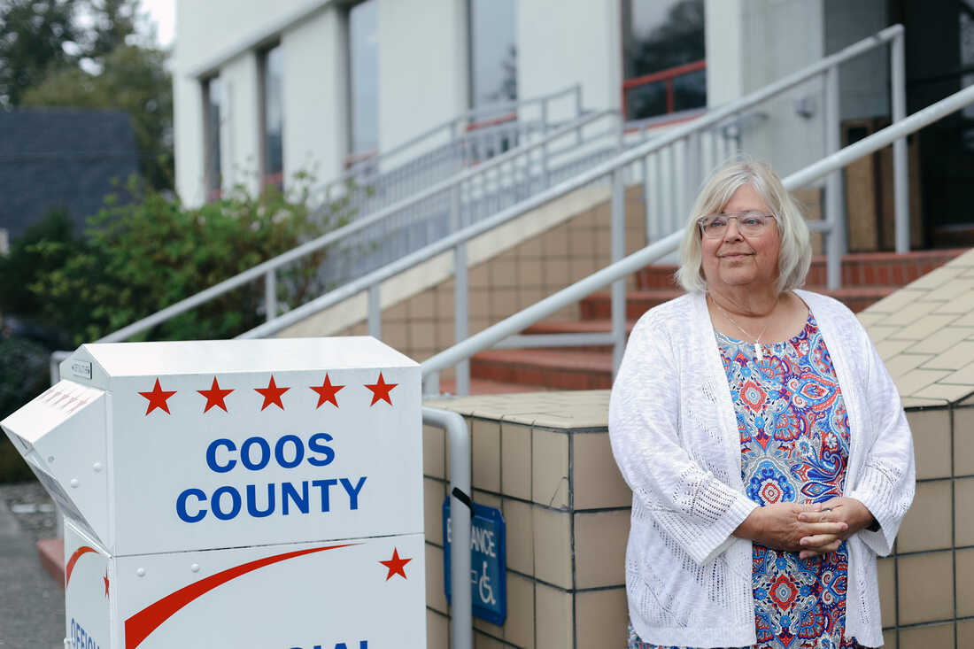

Reference: <https://www.npr.org/2023/06/21/1180818978/election-workers-are-facing-threats-and-harassment-as-they-brace-for-2024>

<div style="display:relative; margin:0px; padding:0px"><img style="width: 1200px; height: 800px; margin:0px; padding:0px" src="**https://ohsu.ca1.qualtrics.com/CP/Graphic.php?IM=IM_xgKkf5mhOnIO5F3"**></div>

<div style="position:relative; margin:0px; padding:0px; top:-8px; height:100px; width:100%; background-color:lightgray; padding:10px; font-weight:bold; font-size:1.3em">**For election workers, Trump's lies have meant threats, harassment and a poisoned dog**<img style="width: 25px; height: 25px;" src="https://ohsu.ca1.qualtrics.com/CP/Graphic.php?IM=IM_0pSmTtfRTtUtj3o"></div>

## 08

### Missing 2020 poll tallies in Georgia don’t prove 20,713 votes never existed. Other records are available

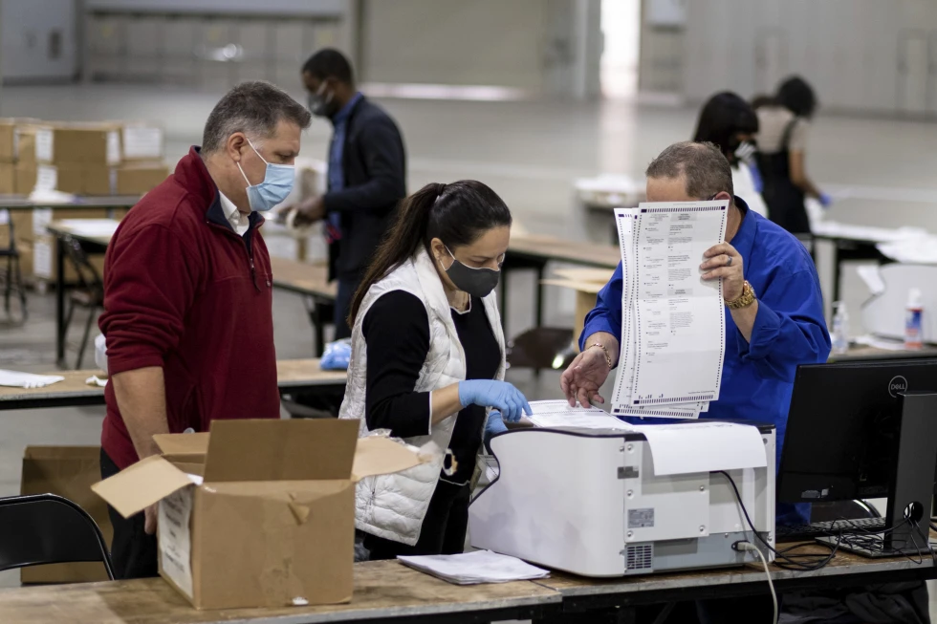

Reference: <https://apnews.com/article/fact-check-2020-fulton-county-georgia-20713-votes-504105499507>

<div style="display:relative; margin:0px; padding:0px"><img style="width: 1200px; height: 800px; margin:0px; padding:0px" src="**https://ohsu.ca1.qualtrics.com/CP/Graphic.php?IM=IM_lq65zZForWlaUs3"**></div>

<div style="position:relative; margin:0px; padding:0px; top:-8px; height:100px; width:100%; background-color:lightgray; padding:10px; font-weight:bold; font-size:1.3em">**Missing 2020 poll tallies in Georgia don’t prove 20,713 votes never existed. Other records are available**<img style="width: 25px; height: 25px;" src="https://ohsu.ca1.qualtrics.com/CP/Graphic.php?IM=IM_0pSmTtfRTtUtj3o"></div>

## 09

### Trump is not immune from prosecution in his 2020 election interference case, US appeals court says

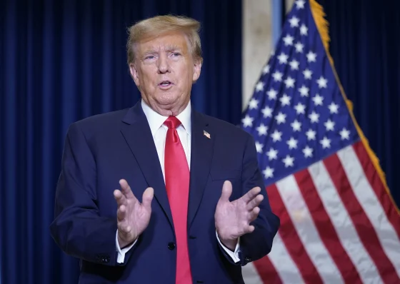

Headline reference: <https://apnews.com/article/trump-capitol-riot-presidential-immunity-appeal-46c2d7fc7807cd3262764d35e47f390e>

Image reference: <https://www.nbcnews.com/politics/supreme-court/appeals-court-rules-trump-presidential-immunity-2020-election-interfer-rcna133234>

<div style="display:relative; margin:0px; padding:0px"><img style="width: 1200px; height: 800px; margin:0px; padding:0px" src="**https://ohsu.ca1.qualtrics.com/CP/Graphic.php?IM=IM_QLU9AGt9rsWgoF2"**></div>

<div style="position:relative; margin:0px; padding:0px; top:-8px; height:100px; width:100%; background-color:lightgray; padding:10px; font-weight:bold; font-size:1.3em">**Trump is not immune from prosecution in his 2020 election interference case, US appeals court says**<img style="width: 25px; height: 25px;" src="https://ohsu.ca1.qualtrics.com/CP/Graphic.php?IM=IM_0pSmTtfRTtUtj3o"></div>

## 10

### Florida man charged with throwing explosive at Capitol riot



Reference: <https://apnews.com/article/capitol-insurrection-florida-arrest-106785e4acbf246796476ffadb640116>

<div style="display:relative; margin:0px; padding:0px"><img style="width: 1200px; height: 800px; margin:0px; padding:0px" src="**https://ohsu.ca1.qualtrics.com/CP/Graphic.php?IM=IM_AJyQtaBbWi5AxDh"**></div>

<div style="position:relative; margin:0px; padding:0px; top:-8px; height:100px; width:100%; background-color:lightgray; padding:10px; font-weight:bold; font-size:1.3em">**Florida man charged with throwing explosive at Capitol riot**<img style="width: 25px; height: 25px;" src="https://ohsu.ca1.qualtrics.com/CP/Graphic.php?IM=IM_0pSmTtfRTtUtj3o"></div>

## 11

### Records in Fox defamation case show pressures on reporters



Reference: <https://apnews.com/article/fox-news-journalism-election-dominion-defamation-9b33fc9ca1e11fc0b49e2f437fc60007>

<div style="display:relative; margin:0px; padding:0px"><img style="width: 1200px; height: 800px; margin:0px; padding:0px" src="**https://ohsu.ca1.qualtrics.com/CP/Graphic.php?IM=IM_Tf6KnPX57wUh637"**></div>

<div style="position:relative; margin:0px; padding:0px; top:-8px; height:100px; width:100%; background-color:lightgray; padding:10px; font-weight:bold; font-size:1.3em">**Records in Fox defamation case show pressures on reporters**<img style="width: 25px; height: 25px;" src="https://ohsu.ca1.qualtrics.com/CP/Graphic.php?IM=IM_0pSmTtfRTtUtj3o"></div>

## 12

### Tucker Carlson amplifies Jan. 6 lies with GOP-provided video

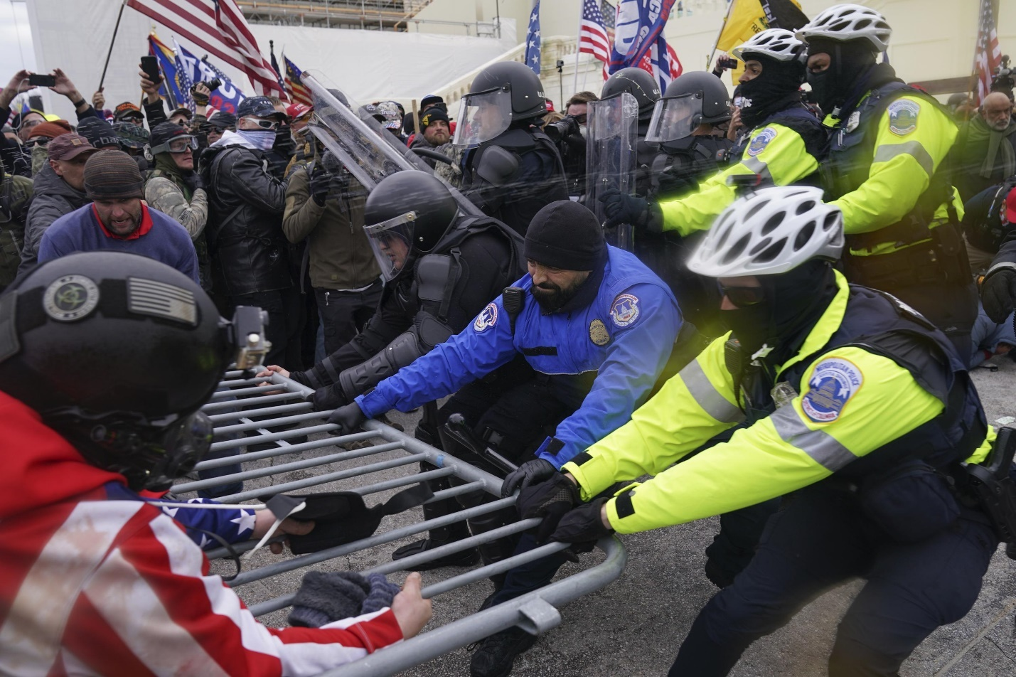

Headline reference: <https://apnews.com/article/jan-6-tucker-carlson-capitol-riot-mccarthy-adc245e22f50b076925eb72948062808>

Image reference: <https://apnews.com/article/jan-6-tucker-carlson-capitol-riot-mccarthy-adc245e22f50b076925eb72948062808>

<div style="display:relative; margin:0px; padding:0px"><img style="width: 1200px; height: 800px; margin:0px; padding:0px" src="**https://ohsu.ca1.qualtrics.com/CP/Graphic.php?IM=IM_cgMT2kKh1UFSn8S"**></div>

<div style="position:relative; margin:0px; padding:0px; top:-8px; height:100px; width:100%; background-color:lightgray; padding:10px; font-weight:bold; font-size:1.3em">**Tucker Carlson amplifies Jan. 6 lies with GOP-provided video**<img style="width: 25px; height: 25px;" src="https://ohsu.ca1.qualtrics.com/CP/Graphic.php?IM=IM_0pSmTtfRTtUtj3o"></div>

## 13

### New US House speaker tried to help overturn the 2020 election, raising concerns about the next one

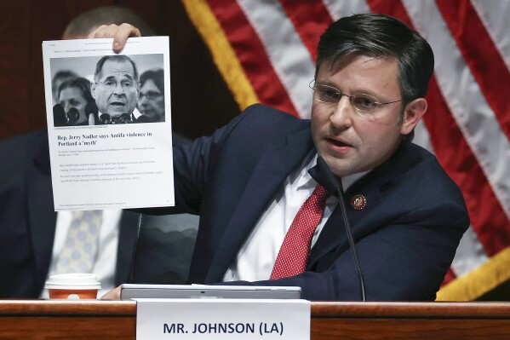

Reference: <https://apnews.com/article/congress-house-speaker-2024-election-certification-8cd7c5a9e6ae69635bbb4624cc78e5c5>

<div style="display:relative; margin:0px; padding:0px"><img style="width: 1200px; height: 800px; margin:0px; padding:0px" src="**https://ohsu.ca1.qualtrics.com/CP/Graphic.php?IM=IM_3JQVfRfrNlrhRUJ"**></div>

<div style="position:relative; margin:0px; padding:0px; top:-8px; height:100px; width:100%; background-color:lightgray; padding:10px; font-weight:bold; font-size:1.3em">**New US House speaker tried to help overturn the 2020 election, raising concerns about the next one**<img style="width: 25px; height: 25px;" src="https://ohsu.ca1.qualtrics.com/CP/Graphic.php?IM=IM_0pSmTtfRTtUtj3o"></div>

## 14

### Michigan charges 16 fake electors for Donald Trump with election law and forgery felonies

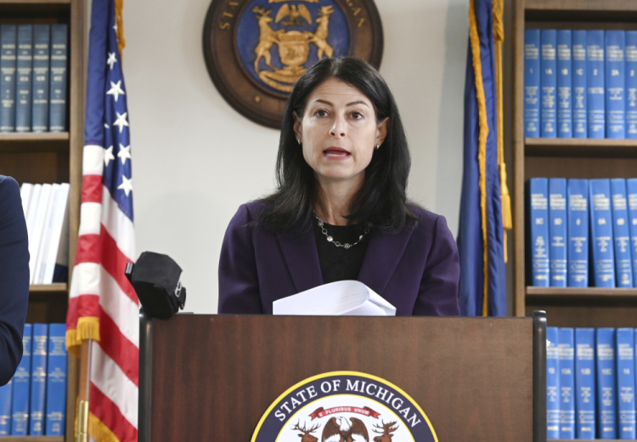

Headline reference: <https://apnews.com/article/fake-elector-michigan-republican-df7803fca3862be713d9d6d29fb77e81>

Image reference: <https://www.pressherald.com/2023/07/18/michigan-charges-16-fake-electors-for-donald-trump-with-election-law-and-forgery-felonies/>

<div style="display:relative; margin:0px; padding:0px"><img style="width: 1200px; height: 800px; margin:0px; padding:0px" src="**https://ohsu.ca1.qualtrics.com/CP/Graphic.php?IM=IM_3fQx9SQ1TX0CNkD"**></div>

<div style="position:relative; margin:0px; padding:0px; top:-8px; height:100px; width:100%; background-color:lightgray; padding:10px; font-weight:bold; font-size:1.3em">**Michigan charges 16 fake electors for Donald Trump with election law and forgery felonies**<img style="width: 25px; height: 25px;" src="https://ohsu.ca1.qualtrics.com/CP/Graphic.php?IM=IM_0pSmTtfRTtUtj3o"></div>

## 15

### Trump’s target letter suggests the sprawling US probe into the 2020 election is zeroing in on him

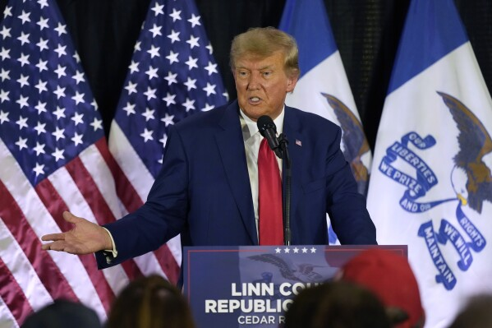

Reference: <https://apnews.com/article/trump-jan-6-justice-department-charges-ab1ad197e9abcb3eb9095237b98bee7d>

<div style="display:relative; margin:0px; padding:0px"><img style="width: 1200px; height: 800px; margin:0px; padding:0px" src="**https://ohsu.ca1.qualtrics.com/CP/Graphic.php?IM=IM_VbcVO2c9cjGoRwK"**></div>

<div style="position:relative; margin:0px; padding:0px; top:-8px; height:100px; width:100%; background-color:lightgray; padding:10px; font-weight:bold; font-size:1.3em">**Trump’s target letter suggests the sprawling US probe into the 2020 election is zeroing in on him**<img style="width: 25px; height: 25px;" src="https://ohsu.ca1.qualtrics.com/CP/Graphic.php?IM=IM_0pSmTtfRTtUtj3o"></div>

## 16

### Georgia’s top court rejects Trump attempt to thwart prosecutor in 2020 election investigation

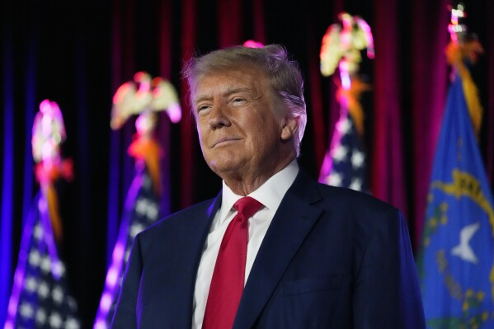

Reference: <https://apnews.com/article/trump-georgia-grand-jury-election-485ca85e57fd80af7455a59174d10d4f>

<div style="display:relative; margin:0px; padding:0px"><img style="width: 1200px; height: 800px; margin:0px; padding:0px" src="**https://ohsu.ca1.qualtrics.com/CP/Graphic.php?IM=IM_cw7zu7wcG5Fdcqf"**></div>

<div style="position:relative; margin:0px; padding:0px; top:-8px; height:100px; width:100%; background-color:lightgray; padding:10px; font-weight:bold; font-size:1.3em">**Georgia’s top court rejects Trump attempt to thwart prosecutor in 2020 election investigation**<img style="width: 25px; height: 25px;" src="https://ohsu.ca1.qualtrics.com/CP/Graphic.php?IM=IM_0pSmTtfRTtUtj3o"></div>

## 17

### Pastor Among 18 Trump Co-Defendants Arrested in Georgia Election Case

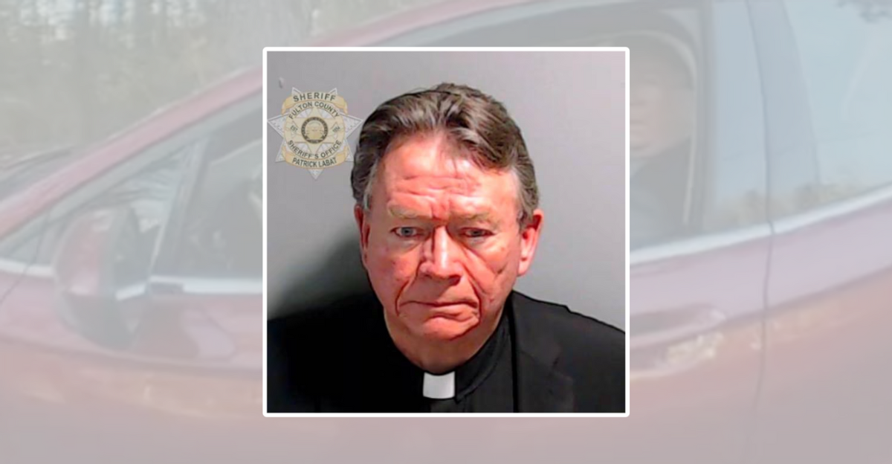

Reference: <https://www.snopes.com/fact-check/pastor-trump-codefendant-georgia-election-case/>

<div style="display:relative; margin:0px; padding:0px"><img style="width: 1200px; height: 800px; margin:0px; padding:0px" src="**https://ohsu.ca1.qualtrics.com/CP/Graphic.php?IM=IM_tAvkJNsqjgyABMl"**></div>

<div style="position:relative; margin:0px; padding:0px; top:-8px; height:100px; width:100%; background-color:lightgray; padding:10px; font-weight:bold; font-size:1.3em">**Pastor Among 18 Trump Co-Defendants Arrested in Georgia Election Case**<img style="width: 25px; height: 25px;" src="https://ohsu.ca1.qualtrics.com/CP/Graphic.php?IM=IM_0pSmTtfRTtUtj3o"></div>

# Attention Check

## 01

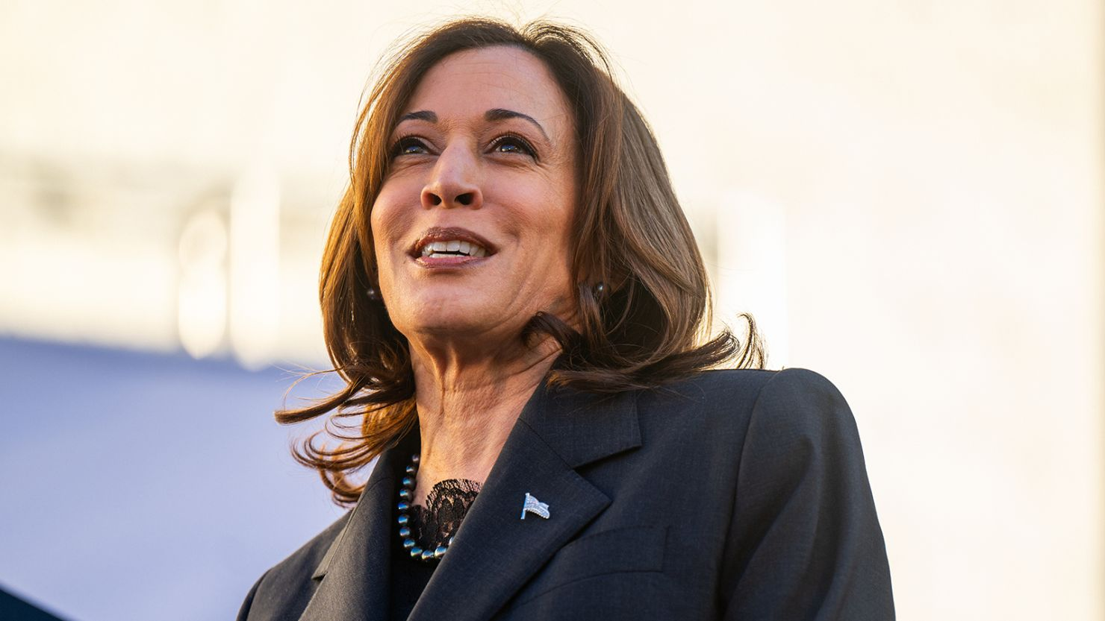

Reference: <https://www.cnn.com/2024/02/07/politics/harris-set-to-host-democratic-governors-this-weekend-to-discuss-2024-campaign/index.html>

<div style="display:relative; margin:0px; padding:0px"><img style="width: 1200px; height: 800px; margin:0px; padding:0px" src="**https://ohsu.ca1.qualtrics.com/CP/Graphic.php?IM=IM_6Dydse0JciUH1Nc"**></div>

<div style="position:relative; margin:0px; padding:0px; top:-8px; height:75px; width:100%; background-color:lightgray; padding:10px; font-weight:bold; font-size:1.3em">**This headline is an attention check**<img style="width: 25px; height: 25px;" src="https://ohsu.ca1.qualtrics.com/CP/Graphic.php?IM=IM_0pSmTtfRTtUtj3o"></div>

## 02

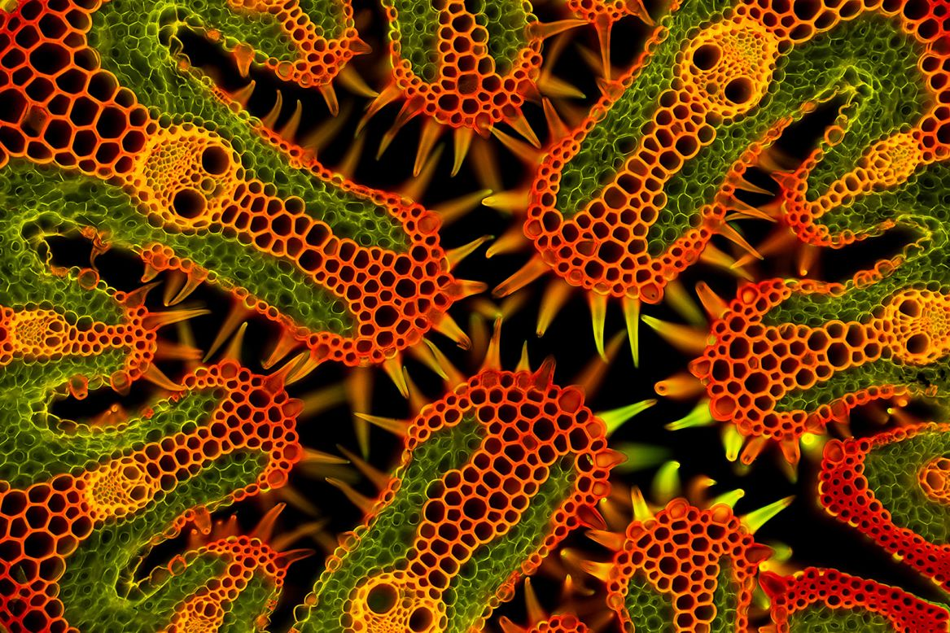

Reference: <https://www.cnn.com/travel/gallery/close-up-photographer-of-the-year-c2e-spc-intl/index.html>

<div style="display:relative; margin:0px; padding:0px"><img style="width: 1200px; height: 800px; margin:0px; padding:0px" src="**https://ohsu.ca1.qualtrics.com/CP/Graphic.php?IM=IM_0fCgQ008TGxKIzc"**></div>

<div style="position:relative; margin:0px; padding:0px; top:-8px; height:75px; width:100%; background-color:lightgray; padding:10px; font-weight:bold; font-size:1.3em">**This headline is an attention check**<img style="width: 25px; height: 25px;" src="https://ohsu.ca1.qualtrics.com/CP/Graphic.php?IM=IM_0pSmTtfRTtUtj3o"></div>